Perception of civil servant’s on APIP capability as moderating variable on the relationship between the implementation of SPIP and SAKIP (study on Salatiga city government)
Limpat Akbar Yudanto, David Adechandra Ashedica Pesudo
^{1,2} Satya Wacana Christian University, Jl. Diponegoro No. 52-60, Sidorejo, Salatiga, 50711, Jawa Tengah, Indonesia

ARTICLE INFO  Article history:  Received 27 March 2020  Revised 22 September 2020  Accepted 24 September 2020  JEL Classification:  M41  Keywords:  Internal control system, accountability, internal auditor capability  DOI:  10.14414/tiar.v10i2.2140 |  | ABSTRACT  This study discusses the government’s accountability performance. This study tried to obtain the evidence on the effect of SPIP (internal control system) Implementation on the SAKIP (accountability performance) implementation and APIP (internal auditor) Capability can strengthen the relationship between SPIP Implementation and SAKIP Implementation. This study helps to improve comprehension of the importance of the implementation of SPIP and the implementation of SAKIP to improve accountability performance as government and the importance of APIP capability can affect the relationship between the implementation of SPIP and SAKIP. It used the sampe consisting of 322 civil servants of Salatiga City Government. The variables used in this study include the dependent variable-SAKIP Implementation, the independent variable-SPIP Implementation, and the moderating variable-APIP Capability. This study uses primary data obtained from civil servants of Salatiga City Government. This data is a cross-section in the form of questionnaires using Moderated Regression Analysis with SPSS. The results show that SPIP Implementation affects SAKIP Implementation and APIP Capability strengthen the relationship between SPIP Implementation and SAKIP Implementation.
ABSTRAK
Studi ini membeahas performa akuntabilitas pemerintah yang bertujuan untuk mendapatkan bukti tentang efek implementasi SPIP (sistem pengendalian intern Pemerintah) merupakan system pengendalian internal terhadap organisasi pemerintah untuk mencapai tujuan organisasi terhadap implementasi SAKIP (Sistem Akuntabilitas Kinerja Instansi Pemerintah) sebagai akuntabilitas kinerja instansi pemerintah dan pengukuran ketercapaian organisasi pemerintah untuk menjadi Lembaga yang akuntabel dan Kapabilitas APIP (Aparat Pengawas Internal Pemerintah) sebagai auditor internal pemerintah dapat memberikan pengawasan dan menjadi konsultan yang mampu menguatkan hubungan antara impelentasi SPIP dan implementasi SAKIP. Studi ini membantu meningkatkan pemahaman tentang pentingnya implementasi SPIP dan implementasi SAKIP untuk meningkatkan performa akuntabilitas sebagai pemerintah dan pentingnya kapabilitas APIP berdampak pada hubungan implementasi SPIP dan SAKIP. Sample terdiri dari 322 aparatur sipil negara di Pemerintah Kota Salatiga. Variabel-variabel yang digunakan dalam studi ini antara lain variabel terikat-implementasi SAKIP, variabel bebas-implementasi SPIP, dan variabel moderasi-Kapabilitas APIP. Studi ini menggunakan data primer berasal aparatur sipil negara di lingkungan Pemerintah Kota Salatiga. Studi ini menggunakan data cross section dalam bentuk kuisioner menggunakan Moderated Regression Analysis dengan SPSS. Hasil menunjukkan bahwa implementasi SPIP berdampak kepada implementasi SAKIP dan Kapabilitas APIP dapat menguatkan hubungan antara implementasi SPIP dan implementasi SAKIP.

1. Introduction
* Corresponding author, email address: limpatakbar@gmail.com
A local government is a form of public administration which—in a majority of contexts— exists as the lowest tier of administration within a given state (Pemerintah Republik Indonesia, 2014). For that reason, the minister/head of institution, governor, and regents/mayor must implement control over the organizing of government activities to achieve efficient, effective, accountable and transparent financial management, (Pemerintah Republik Indonesia, 2008). The leaders of local government work units must also implement the Internal Government Control System (Sistem Pengendalian Internal Pemerintah, hereinafter referred to as SPIP) as an integral part of Local Government Work Unit (Satuan Kerja Perangkat Daerah, hereinafter referred as SKPD) activities (Walikota Kota Salatiga, 2011).
The internal control of government is conducted by Government Internal Control Apparatus (Aparatur Pengawas Intern Pemerintah, hereinafter referred to as APIP) (Pemerintah Republik Indonesia, 2008). The city inspectorate is an official government internal control apparatus in the level of city government (Pemerintah Republik Indonesia, 2008). The Inspectorate of Salatiga city can be regarded as the internal auditor in the government of Salatiga. The capability of the internal auditors is a detailed knowledge that internal auditors must have to conduct their jobs properly so that the purpose of internal audit can be achieved. Civil servant’s perception on APIP capability is needed to measure how well the capability of APIP as internal auditors.
Every head of government needs to perform accountability of government agencies as a form of accountability of government agencies in achieving the organizational mission and objectives (Presiden Republik Indonesia, 1999). Head of local government work unit as a user of budget compiles performance report and submits it to the governor/regent/mayor, and Minister of State Utilization of State Apparatus (Pemerintah Republik Indonesia, 2006). Performance report has resulted from Accountability Performance of Government Agency System (Sistem Akuntabilitas Kinerja Instansi Pemerintah, hereinafter referred to as SAKIP) organized by each reporting entity and/or accounting entity (Pemerintah Republik Indonesia, 2006). The implementation of SAKIP is carried out to prepare the performance report under laws and regulations (Presiden Republik Indonesia, 2014). Every leader of a government agency evaluates the implementation of SAKIP (Kementerian Pemberdayagunaan Aparatur Negara dan Reformasi Birokrasi, 2015).
Although in 2011 the Mayor of Salatiga issued a regulation to implement SPIP, the implementation started in 2016. The benefit of SPIP implementation is seen from the decreasing number of audit finding from 2015 until 2018. Based on Inspektorat Kota Salatiga, (2015-2018) as an internal auditor of the Salatiga government, there were 489 audit findings in 2015, 397 in 2016, 369 in 2017, and 255 in 2018. The decreasing number of audit findings was followed by the increasing result of SAKIP from 2015 until 2018. Based on Kementerian Pemberdayagunaan Aparatur Negara dan Reformasi Birokrasi, (2015-2018) Salatiga government got a C (deficient) predicate with 44.24 points in 2015, a CC (sufficient) predicate with 56.95 points in 2016, a CC (sufficient) predicate with 57.74 points in 2017, and a B (good) predicate with 63.03 in 2018.
Based on the data above, there is a positive relationship between the implementation of SPIP and SAKIP. In 2015 before the implementation of SPIP, the Salatiga government only got a C (deficient) predicate on the scoring of SAKIP. After the implementation of SPIP in 2016, the Salatiga government score of SAKIP has been rising every year until 2018. It means that the implementation of SPIP affected the implementation of SAKIP.
Internal control has a significant direct relationship with accountability (Sari, Ghozali and Achmad, 2017). Introducing the control factors of internal control will contribute to the improvement of accountability (Aziz, Said and Alam, 2015). There is a positive link between the need for internal control system and accountability (Sarens and Christopher, 2010). The internal control system has a positive impact on accountability (Avery and Obah, 2018). The effect of internal control was insignificant toward the accountability of the public sector (Alam, Said and Aziz, 2018). Internal Control System has a negative significant effect on the accountability in Regency/City Governments (Purbasari and Bawono, 2017). To improve the research in this field, this study uses a civil servant’s perception of APIP capability as a moderating variable that affects the relationship between the implementation of SPIP and SAKIP.
This study uses a quantitative approach that aims to determine whether the implementation of SPIP affects the implementation of SAKIP or not and to find whether the capability of government internal control apparatus affects the relationship between the implementation of government internal control systems and the implementation of accountability performance of government agency system.
This study was conducted in Salatiga regional work units to obtain information about civil servants' perception of the implementation of government internal control system (SPIP), civil servant’s perception of Government Internal Control Apparatus (APIP) capability and the implementation of accountability performance of government agency system. From that explanation, this research has a research problems: whether the implementation of government internal control system (SPIP) affects the implementation of accountability performance of government agency system (SAKIP) and whether Government Internal Control Apparatus (APIP) capability can moderate the relationship between SPIP dan SAKIP.
This study is expected to give benefits to several parties. For the Salatiga government, this study helps to improve comprehension of the importance of the implementation of SPIP and the implementation of SAKIP to improve accountability performance as government and the importance of APIP capability that can affect the relationship between the implementation of SPIP and SAKIP. For every work unit of Salatiga, this study helps to measure the level of implementation of SPIP. For academics, this study helps to enrich the literature review about the implementation of SPIP and SAKIP.

2. THEORETICAL FRAMEWORK AND HYPOTHESES
Stewardship Theory
Donaldson & Davis, (1991) stated that stewardship theory is the condition in which organizations are not interested in individual interest and they only focuse on the organizational interest to achieve organizational objectives. In this study, the local government has a role as a steward and the public has a role as a principal. In stewardship theory, the steward needs to improve its performance to satisfy the principal. Local government has an objective to improve the accountability performance so that it will become an accountable organization. By becoming an accountable organization, the government will gain trust and satisfaction from the public as principal. The implementation of SPIP is created to improve government official’s performance and reduce the risk of fraud. The good performance of civil servants and the reluctance of civil servants to do fraud will turn them into good steward so that the government can achieve its objectives easier. The implementation of SAKIP aims to improve the accountability performance. The purpose of the implementation of SAKIP is to create accountable government agencies. The accountability of the government is very important to determine whether the government is a good steward or not. The implementation of SPIP is expected to help the improvement of SAKIP implementation.

Accountability Performance of Government Agency System (SAKIP)
Accountability is known as the duty of an organization to account for its activities, accept responsibility for them and disclose the result in a transparent way (Alam, Said and Aziz, 2018). The connection between people to take, demonstrate, and review responsibility for performance called accountability (Johari, Alam and Said, 2018). The public sector such as the government needs to show its accountability by answering the usage of public resources (Said and Alam, 2018). Based on the Presiden of Republik Indonesia, (2014), accountability performance is a form of government agency's responsibility to measure how good the activities conducted by the government as a steward of the public. To measure accountability performance, the government of Indonesia established Accountability Performance of Government Agency System or known as SAKIP.
The measurement of SAKIP is based on several indicators such as performance planning, performance measurement, performance reporting, internal evaluation, and performance achievements (Kementerian Pemberdayagunaan Aparatur Negara dan Reformasi Birokrasi, 2015). The total measurement from 5 indicators will be used to determine the score of accountability performance of government agencies. The scoring of SAKIP are classified into several predicates, based on Kementerian Pemberdayagunaan Aparatur Negara dan Reformasi Birokrasi, (2015) there are 7 predicates: D (very deficient) predicate with 0-30% points, C (deficient) predicate with >30%-50% points, CC (sufficient) predicate with >50%-60% points, B (good) predicate with >60%-70% points, BB (very good) predicate with >70%-80% points, A (satisfying) predicate with >80%-90% points, and AA (very satisfying) with >90%-100% points.

Government Internal Control System (SPIP)
Internal control is defined as procedures and policies formed by organizations to help the organizations conduct activities according to established standards (Abubakar, Dibal and Amade, 2017). A good internal control system will give benefits to an organization to help the organization work effectively and harmoniously at the time of detecting errors and irregularities in its operation (Alam, Said and Aziz, 2018). SAKIP adopted the COSO, consisting of the control environment; risk assessment; control activities; information and communication; while internal control monitoring is defined as a process, effected by stakeholders, to provide reasonable assurance about the achievement of objectives (Sari, Ghozali and Achmad, 2017). According to Pemerintah Republik Indonesia, (2008) government control will improve accountability through evaluation and improvement in internal control. Based on Walikota Kota Salatiga, (2011), SPIP has 5 components such as control environment, risk assessment, control activities, information and communication, and internal control monitoring.
Control Environment is a set of the tone of organization to influence the control consciousness of organizations members (Commite of Sponsoring Organizations of Treadway Commission, 2013). There are several aspects associated with control environment such as enforcement of integrity and ethical values, commitment to competence, conductive leadership, drafting organizational structure and formulation of job descriptions according to needs organization, delegation of authority and responsibility right, preparation and implementation of sound policies about fostering human resources, embodiment of the role of internal control apparatus, and good relationship with other government work units (Walikota Kota Salatiga, 2011).
Risk Assessment is a stage where people want to get their control right by focusing on prioritized risks (Commite of Sponsoring Organizations of Treadway Commission, 2013). The Head of government work unit needs to conduct a risk assessment based on risk identification and risk analysis (Walikota Kota Salatiga, 2011).
Control activities are the procedures and policies to help stakeholders to conduct activities according to the established standards (Commite of Sponsoring Organizations of Treadway Commission, 2013). To conduct control activities, the head of government work unit needs to use four characteristics such as control activities, which are prioritized on government work unit principal activities. Control activities must be associated with the risk assessment process. Selected control activities are adjusted with the special nature of government work units, and policies and procedures must be written and established (Walikota Kota Salatiga, 2011).
Information supports the internal control to achieve organization’s objectives and communication is a process of sharing, obtaining, and providing information (Commite of Sponsoring Organizations of Treadway Commission, 2013). The head of government work unit needs to provide and utilize various forms and means of communication and also manage, develop, and renew the information system continuously (Walikota Kota Salatiga, 2011).
The internal control system needs to be monitored as a process that assesses the quality of the system’s performance over time (Commite of Sponsoring Organizations of Treadway Commission, 2013). The head of government work unit must monitor the internal control system with some aspects such as continuous monitoring, separate evaluation, following up on audit recommendations and reviewing other recommendations (Walikota Kota Salatiga, 2011).

Government Internal Control Apparatus (APIP) Capability
The capability of Government Internal Control Apparatus (APIP) is being able to conduct supervisory tasks that consist of three elements such as capacity, authority, and competency. These must be owned by internal control apparatus to manifest the effectivity role of internal control apparatus (BPKP, 2011). The capability assessment of the internal control apparatus is conducted based on the Internal Audit Capability Model (IA-CM) that has the purpose to find the areas of improvement for every internal control apparatus (BPKP, 2011). Internal Audit Capability model is a model framework developed by The Institute of Internal Auditors (IIA). Based on the Institute of Internal Auditors, (2009), the internal audit capability model has a purpose to improve the quality of internal auditors.
BPKP, (2011) stated that the Internal Audit Capability model is a communication media, a framework for assessment, and a road map for orderly improvement. There are 5 levels in classifying the capability of internal control apparatus: Level 1 (Initial), Level 2 (Infrastructure), Level 3 (Integrated), Level 4 (Managed) and Level 5 (Optimized). The classification level of the capability has the purpose to measure the capability of the internal control apparatus.

Implementation of SPIP on Implementation of SAKIP
Previous study found that internal control affects accountability. Control and accountability are a mechanism that interacts with each other (Aristanti, 2015). The role of internal control is to support the system established at the time of fostering the decision maker’s accountability (Bianchi, 2010). The higher level of the control system will lead to a higher expectation of accountability in the organization (Liu, 2011). Control environment, risk assessment, control activities, information and communication, and monitoring influence accountability (Febriana, Wardayati and Prasetyo, 2017). The implementation of internal control will make the accountability of the local government get better (Kewo, 2017). There is a significant positive relationship between the internal control system, prudence, and accountability (Wakiriba, Ngahu and Wagoki, 2014). Internal control system is created to emphasize accountability (Alam, Said and Aziz, 2018). From the explanation, the author can formulate the first hypothesis as follows:
H1: The Implementation of SPIP affects the Implementation of SAKIP

The Implementation of SPIP on The Implementation of SAKIP with APIP Capability as a moderating effect
The capability of the government internal auditor represents the quality of the internal auditor. APIP that has capability can give better quality to help implementation of internal control because as the internal auditors, APIP has to facilitate and guide the implementation of SPIP. Internal auditor competency has a positive impact on the internal control (Oussii and Taktak, 2018). The internal auditor role affects internal control (Rini and Fitri, 2015). The capability of APIP has a positive effect on the accountability performance of the government agency system (Suharyanto, Mahullete, Meiria, 2018). The internal auditor capability gives a positive impact both on internal control and accountability performance. It means that the capability of APIP as the internal auditor will strengthen the relationship between the implementation of SPIP and SAKIP. On the other hand, lacks of APIP capability will weaken the relationship between the implementation of SPIP and SAKIP. The author argues that APIP capability can moderate the relationship between the implementation of SPIP and SAKIP. From the explanation, the author can formulate the second hypothesis as follows:
H2: The Internal Control Apparatus (APIP) capability moderates the relationship between Government Internal Control System (SPIP) and Accountability Performance of Government Agency System (SAKIP)

Model Framework
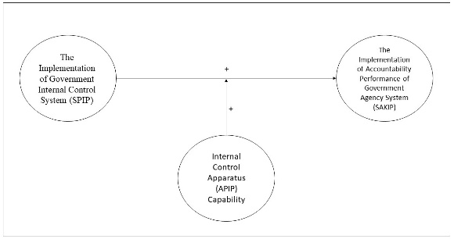
Figure 1
APIP Capability as moderating variable on the relationship between implementation of SPIP and implementation of SAKIP

3. RESEARCH METHOD
This study uses a quantitative approach to check the hypotheses whether the implementation of SPIP affects the implementation of SAKIP and the moderating effect of civil servant’s perception of APIP capability on the relationship between Implementation SPIP and the implementation of SAKIP. The data of this study is primary data taken from the questionnaire with the structural civil servants who work in Salatiga Government as respondents. Moderating regression analysis was used to prove the hypotheses.

Population and Sample
The population of this data is structural civil servants as the perpetrators of management organization. Management organization consists of planning, organizing, actuating, and controlling. The implementation of the government internal control system is as a form of actualization of controlling in management organization. Based on Badan Kepegawaian dan Pendidikan Diklat Daerah Kota Salatiga, (2019) the total of structural civil servants amounted by 1,639 with the details are as follows: 29 echelon II officials, 115 echelon III officials, 393 echelon IV officials, and 1102 staffs from 35 government work units in Salatiga. This study uses convenience sampling which means the determination of sampling based on civil servants encountered by the author and the author uses the Slovin formula to determine the amount of sample from four categories above with 0.05 error rate. Based on the Slovin formula . Then the samples in this study amounted to 322.

Data Collection
This research uses primary data and the type of data is cross-section data. The data were taken by using questionnaires fulfilled by the respondents. The data type is cross-section because the data were collected from civil servants from 35 government work units in Salatiga.

Operational Definition
Table 1 shows (appendices) the operational definition in this study. The operational definition contains the name of variable, the definition of a variable, indicator from each variable, and the measurement each variable. The purpose of operational definition is to avoid misunderstanding when collecting data.

Analysis Technique
This study used moderating regression analysis (MRA) because there is a Government Internal Control Apparatus (APIP) capability as a moderating variable. Before conducting the MRA, the author has to conduct validity, reliability, and classic assumption tests. A validity test is used to check whether the questions in the questionnaire are valid or not. The reliability test is used to check whether the questions in the questionnaire are reliable or not. The classic assumption tests consist of a normality test, multicollinearity test, heteroscedasticity test, and linearity test. A normality test is a test to check whether the data is normally distributed or not. A multicollinearity test is a test to check whether there is a correlation in the regression model or not. Heteroscedasticity is a test to check whether there are differences variant from residual or not. After conducting the validity, reliability, and classic assumption tests then the author can conduct moderating regression analysis. The regression model is as follows:

SAKIP = α + β1SPIP + ε
SAKIP = α + β1SPIP + β2APIP+ β3SPIP*APIPCAP + ε
The explanation from our model as follows:
SAKIP = Accountability Performance of Government Agency System
SPIP = Government Internal Control System
APIPCAP = Government Internal Control Apparatus
ε = Error

4. DATA ANALYSIS AND DISCUSSION
Data Analysis
The population in this research amounted to 1,639 civil servants and based on the Slovin formula, the number of samples in this research has amounted to 322. Data collection is taken from government offices in Salatiga City Government. The questionnaires were distributed to 340 civil servants and the number of feedbacks is amounted by 325. Table 2 (appendices) shows the distribution of data.
After collecting the data, the questionnaires were checked to prove that the questionnaires were valid and reliable. A validity and reliability test can be used to check the validity and reliability of the questionnaire. Validity and reliability test are conducted to every question in every variable.
Table 3 (appendices) shows the result of the validity test of SPIP Implementation, SAKIP Implementation, and APIP Capability. Based on the validity test result, every question in the questionnaire has a Pearson Correlation of more than 0.05. It means that every question in the questionnaire is valid.
Table 4 (appendices) shows the result of reliability test of SPIP implementation, SAKIP implementation, and APIP Capability. Based on the reliability test result, Cronbach’s Alpha in every variable is more than 0.70. It means that questions in the questionnaires are reliable.
Table 5 (appendices) shows the normality test to check whether data is normally distributed or not. To check the normality test, this study used Kolmogorov Smirnov Test to check the normality. Based on table 5, the significance is 0.92 and it is more than 0.05. It means that the data is normally distributed.
Figure 2 until 4 (appendices) show the linearity correlation between every two variables. Although some data quite far from the normal line but the rest of the data between SPIP implementation, SAKIP Implementation and APIP Capability near the normal line. It means that the data passed the linearity test.
Figure 5 (appendices) shows the graph about the heteroscedasticity test. Although some data stick together in the one position, but the others spread into various positions. It means that the data passed the heteroscedasticity test.
Table 6 (appendices) shows the result of the multicollinearity Test. The table shows that the tolerance value is 0.700 more than 0.100. VIF is 1.428 less than 10.00. Based on the tolerance value and VIF, it means that the data passed multicollinearity test.
After doing the validity and reliability test and also the classic assumption test, the researchers need to prove the hypothesis. Two hypotheses must be proven. To test hypothesis one, the author used simple linear regression and to check hypothesis two, the author used MRA.
Table 7 (appendices) shows that t is positive 13.052 and the significance is 0.000 or lower than 0.05. This condition implies that SPIP Implementation has a positive relationship with SAKIP Implementation. Based on table 8 (appendices), SPIP Implementation has a positive relationship toward SAKIP implementation amounted by 0.345 or 34.5% and the rest of 66.5% of SAKIP Implementation is influenced by other factors. From the explanation, hypothesis one is accepted.
Table 9 shows that the significance of SPIP Implementation, APIP Capability, and SPIP Implementation multiplied by APIP Capability are less than 0.05. It means they have a significant relationship with SAKIP Implementation. Table 10 shows that the R Square amounted by 0.498 or 49.8%. There is an improving amount of R Square from model one to model two. The existence of APIP Capability strengthens the relationship between SPIP Implementation and SAKIP Implementation. It means that hypothesis two is accepted.

Discussion
The implementation of SPIP will make government’s organizations easier to reach their objectives because of SPIP will make civil servants work in line with standard operating procedures that have been determined. One of the objectives of the government is to be accountable organization to maintain trust from their people. The findings of this research found that SPIP implementation has a positive influence on the implementation of SAKIP. This result shows that H1 is accepted. It means that SPIP implementation gives influence to the government’s organization to be accountable to organizations through SAKIP implementation. The result of this research in line with some previous research for example, based on Avery & Obah, (2018) stated that the internal control system has a positive impact on accountability. The implementation of internal control will make the accountability of the local government get better (Kewo, 2017). The higher level of the control system will lead to higher expectations of accountability in the organization (Liu, 2011). Internal control has a significant direct relationship with accountability (Sari, Ghozali and Achmad, 2017). Introducing the control factors of internal control will contribute to the improvement of accountability (Aziz, Said and Alam, 2015).
APIP has a job to monitor and facilitate the internal control system in the organization. Their effort is related to the accountability. This is because the government’s organization is responsible for maintaining the trust of their people. The capability of APIP is very important because the higher of APIP capability will strengthen the relationship between SPIP implementation and SAKIP implementation. Several previous researchers found that the capability of APIP has a positive effect on the accountability performance of government agency systems (Suharyanto, Mahullete, Meiria, 2018). There are some aspects of APIP capability such as competency and audit role that can influence the internal control system. The previous research stated that auditor competency and audit role as consultant and watchdog for implementing internal control systems through SPIP implementation to drive the improvement of accountability through SAKIP implementation. Internal auditor competency has a positive impact on the internal control (Oussii and Taktak, 2018). The internal auditor role affects internal control (Rini and Fitri, 2015). This research findings in line with the previous research. It means that the APIP Capability influences both of SPIP Implementation and SAKIP Implementation. This research found that the capability of APIP strengthens the relationship between SPIP implementation and SAKIP implementation. The result also proves that H2 is accepted.

5. CONCLUSION, IMPLICATION, SUGGESTION, AND LIMITATIONS
The results of this study show that first; SPIP implementation has a positive effect on the SAKIP implementation. Second, APIP capability strengthens the relationship between SPIP implementation and SAKIP implementation. It means the results of this research can answer the research problems.
The limitation of this study is related to the fifteen questionnaires that could not used for this research because some of them were not complete and the rest of them showed inconsistent answers. Suggestions for future research are on the distribution of data so that the reseacrhers should consider the number of employees in every government work unit. Further study can add more variables such as APIP independence, APIP background, and quality of government financial statement.
Every government work unit in Salatiga should pay attention to the SPIP implementation because SPIP implementation can improve the implementation of SAKIP. On the contrary, the implementation of SPIP will help the government work unit to be more accountable. Every head of government work unit should monitor every activity in organization to increase the level of SPIP implementation.
APIP as the party who facilitates the implementation of SPIP should have good capability to conduct their jobs because the capability of APIP will increase the relationship between SPIP implementation and SAKIP implementation. The Major of Salatiga city government should focus on the improvement of APIP Capability. The capability of APIP can be improved by performing socialization and intense assistance.

REFERENCES
Abubakar, A. A., Dibal, N. A. and Amade, P. (2017) ‘Effect of Internal Control Activity on Financial Accountability and Transparency in Local Government Areas of Borno State , Nigeria’, European Journal of Business and Management, 9(30), pp. 58–65.
Alam, M., Said, J. and Aziz, A. (2018) ‘Role of integrity system , internal control system and leadership practices on the accountability practices in the public sectors of Malaysia’, Social Responsibility Journal, 51(3), pp. 1–23. doi: 10.1108/SRJ-03-2017-0051.
Aristanti, W. (2015) ‘The Influence of Internal Control System on the Financial Accountability of Elementary Schools in Bandung , Indonesia The Influence of Internal Control System on the Financial Accountability of Elementary Schools in Bandung , Indonesia’, Research Journal of Finance and Accounting, 6(January), pp. 89–96.
Avery, B. P. and Obah, O. D. (2018) ‘The Impact of Financial Control on Accountability inthe Public Sector in Nigeria’, IOSR Journal of Economics and Finance, 9(6), pp. 37–56. doi: 10.9790/5933-0906033756.
Aziz, M. A. A., Said, J. and Alam, M. (2015) ‘Assessment of The Practices of Internal Control System in The public Sectors of Malaysia’, Asia-Pacific Management Accounting Journal, 10(1), pp. 1–20.
Badan Kepegawaian dan Pendidikan Diklat Daerah Kota Salatiga (2019) Data Statistik PNS (Golongan Tiap Eselon / Jabatan), http://bkdiklatda.salatiga.go.id/Statistik-Kepegawaian.
Bianchi, C. (2010) ‘Improving Performance and Fostering Accountability in the Public Sector through System Dynamics Modelling : From an “ External ” to an “ Internal ” Perspective’, 384(27), pp. 361–384. doi: 10.1002/sres.
BPKP (2011) Peraturan Kepala BPKP Nomor 1633 Tentang Pedoman Teknis Peningkatan Kapabilitas Aparat Pengawasan Intern Pemerintah.
Commite of Sponsoring Organizations of Treadway Commission (2013) Internal Control — Integrated Framework Executive Summary.
Donaldson, L. and Davis, J. H. (1991) ‘Stewardship Theory or Agency Theory’:, Australian Journal of Management, 16(June 1991), pp. 49–65.
Febriana, L., Wardayati, S. M. and Prasetyo, W. (2017) ‘The Effect of Internal Control Factors on the Accountability of the Auditor at the Inspectirate of Jombang District’, Jurnal Dinamika Akuntansi, 9(2), pp. 166–175.
Inspektorat Kota Salatiga (no date) Rekapitulasi Capaian Tindak Lanjut RHP.
Institute of Internal Auditors (2009) Internal Audit Capability Model (IA-CM) for The Pulblic Sector.
Johari, R. J., Alam, M. and Said, J. (2018) ‘Assessment of management commitment in Malaysian public sector’, Cogent Business & Management. Cogent, 5(00), pp. 1–10. doi: 10.1080/23311975.2018.1469955.
Kementerian Pemberdayagunaan Aparatur Negara dan Reformasi Birokrasi (2015) Peraturan Menteri Pendayagunaan Aparatur Negara Dan Reformasi Birokrasi Republik Indonesia Nomor 12 Tahun 2015 Tentang Pedoman Evaluasi Atas Implementasi Sistem Akuntabilitas Kinerja Instansi Pemerintah.
Kementerian Pemberdayagunaan Aparatur Negara dan Reformasi Birokrasi (no date) Hasil Evaluasi atas Akuntabilitas Kinerja Instansi Pemerintah.
Kewo, C. L. (2017) ‘The Influence of Internal Control Implementation and Managerial Performance on Financial Accountability Local Government in Indonesia’, International Journal of Economics and Financial Issues, 7(1), pp. 293–297.
Liu, O. L. (2011) ‘Outcomes Assessment in Higher Education : Challenges and Future Research in the Context of Voluntary System of Accountability’, Education Measurement Journal, 30(3), pp. 2–9.
Oussii, A. A. and Taktak, N. B. (2018) ‘The impact of internal audit function characteristics on internal control quality’, Managerial Auditing Journal, 33(5), pp. 450–469. doi: 10.1108/MAJ-06-2017-1579.
Pemerintah Republik Indonesia (2006) Peraturan Pemerintah Republik Indonesia Nomor 8 Tahun 2006 Tentang Pelaporan Keuangan dan Kinerja Instansi Pemerintah.
Pemerintah Republik Indonesia (2008) Peraturan Pemerintah Republik Indonesia Nomor 60 Tahun 2008 Tentang Sistem Pengendalian Intern Pemerintah.
Pemerintah Republik Indonesia (2014) Undang-undang Republik Indoensia Nomor 23 Tahun 2014 tentang Pemerintahan Daerah.
Presiden Republik Indonesia (1999) Instruksi Presiden No 7 Tahun 1999 Tentang Akuntabilitas Kinerja Instansi Pemerintah.
Presiden Republik Indonesia (2014) Peraturan Presiden Republik Indonesia Nomor 29 Tahun 2014 Tentang Sistem Akuntabilitas Kinerja Instansi Pemerintah.
Purbasari, H. and Bawono, B. (2017) Pengaruh Desentralisasi Fiskal, Sistem Pengendalian Internal dan Kinerja Pemerintah Daerah Terhadap Akuntantabilitas Laporan Keuangan.
Rini and Fitri, Y. (2015) ‘The Effect of Audit Communitte Role and Internal Control Effectiveness At Islamic Bank Indonesia’, The Journal of Tauhidinomics, 1(1), pp. 81–92.
Said, J. and Alam, M. (2018) ‘Assessment of Accountability Practices in the Public Sector in Malaysia’, Asia-Pacific Management Accounting Journal, 13(1), pp. 167–184.
Sarens, G. and Christopher, J. (2010) ‘The association between corporate governance guidelines and risk management and internal control practices Evidence from a comparative study’, Managerial Auditing Journal, 25(4), pp. 288–308. doi: 10.1108/02686901011034144.
Sari, N., Ghozali, I. and Achmad, T. (2017) ‘The Effect of Internal Audit and Internal Control System on Public Accountability : The Empirical Study in Indonesia State Universities’, International Journal of Civil Engineering and Technology, 8(9), pp. 157–166.
Suharyanto, A. R. Y. et al. (2018) ‘Internal Control and Accountability of Local Government Performance in Indonesia’, in KnE Social Sciences, p. 538. doi: 10.18502/kss.v3i8.2531.
Wakiriba, J. W., Ngahu, S. and Wagoki, J. (2014) ‘Effects Of Financial Controls On Financial Management In Kenya ’ s Public Sector : A Case Of N ational Government Departments In Mirangine Sub-County , Nyandarua County’, IOSR Journal of Business and Management, 16(10), pp. 105–115.
Walikota Kota Salatiga (2011) Peraturan Walikota Salatiga Nomor 34 Tahun 2011 Tentang Penyelenggaraan Sistem Pengendalian Intern Pemerintah. doi: 10.3969/j.issn.1006-8082.2011.06.013.

Appendices
Table 1
Operational Definition

Variables | Definitions | Indicators | Measurements
Implementation of Accounting Performance of Government Agency System (SAKIP) | The accountability performance of the government agency system is a system that is implemented to measure the accountability of government agencies. | There are five indicators of SAKIP implementation:  - Performance Planning  - Performance Measurement  - Performance Reporting  - Internal Evaluation  - Performance Achievement | The measurement of SAKIP Implementation classified into 5 predicates:  - Strongly Disagree with 1 point  - Disagree with 2 points  - Neutral with 3 points  - Agree with 4 points  - Strongly Agree with 5 points
Implementation of Government Internal Control System (SPIP) | Government's internal control system is a system to implement internal control as one of the government’s efforts to improve its performance. | There are five indicators of SPIP implementation:  - Control Environment  - Risk Assessment  - Control Activities  - Information and Communication  - Internal Control Monitoring | The measurement of SPIP Implementation classified into 5 levels:  - Level 1 (initial) with 1 point  - Level 2 (structured) with 2 points  - Level 3 (integrated) with 3 points  - Level 4 (managed) with 4 points  - Level 5 (optimized) with 5 points
Civil Servant’s Perception of Government Internal Control Apparatus (APIP) Capability | Government Internal Control Apparatus (APIP) Capability is an ability that must be owned by the government's internal control apparatus to conduct their jobs as internal auditors. | There are five indicators of civil servant’s perception of APIP capability:  - Adequate confidence in obedience, frugality, efficiency, and effectiveness  - Risk Alarm  - Maintenance and Quality improvement | The measurement of APIP capability classified into 5 levels:  - Strongly Disagree with 1 point  - Disagree with 2 points  - Neutral with 3 points  - Agree with 4 points  - Strongly Agree with 5 points

Table 2
Distribution of Data
Office’s Name | Number of Questionnaires
Dinas Perpustakaan dan Kearsipan Daerah | 10
Bagian Kesejahteraan Rakyat Setda | 5
Badan Keuangan Daerah | 25
Kecamatan Sidomukti | 9
Kecamatan Sidorejo | 10
Dinas Pemuda dan Olahraga | 10
Dinas Pekerjaan Umum dan Penataan Ruang | 10
Dinas Kesehatan Kota | 10
Dinas Sosial | 10
Badan Kesatuan Bangsa dan Politik | 9
Bagian Tata Pemerintahan Setda | 5
Dinas Komunikasi dan Informasi | 9
Inspektorat | 10
Dinas Koperasi, Usaha kecil, dan Menengah | 9
Badan Perencanaan, Pembangunan, Penelitian dan Pengembangan Daerah | 11
Badan Kepegawaian, Pendidikan, dan Pelatihan Daerah | 9
Dinas Pemberdayaan Perempuan dan Perlindungan Anak | 9
Kecamatan Argomulyo | 10
Dinas Perumahan dan Kawasan Permukiman | 9
Dinas Perhubungan | 10
Dinas Pangan | 10
Bagian Hubungan Masyarakat dan Protokol Setda | 5
Dinas Pendidikan | 9
Dinas Penanaman Modal dan Pelayanan Terpadu Satu Pintu | 9
Kecamatan Tingkir | 8
Dinas Perindustrian dan Tenaga Kerja | 9
Dinas Pertanian | 10
Satuan Polisi Pamong Praja | 10
Sekretariat DPRD | 9
Dinas Kebudayaan dan Pariwisata | 8
Dinas Perdagangan | 9
Dinas Pengendalian Penduduk dan Keluarga Berencana | 10
Dinas Lingkungan Hidup | 7

Table 3
Validity Test of SPIP Implementation, SAKIP Implementation, APIP Capability
Variable | Pearson Correlation | Explanation
SPIP Implementation
Q1 | 0.860 | Valid
Q2 | 0.823 | Valid
Q3 | 0.840 | Valid
Q4 | 0.855 | Valid
Q5 | 0.839 | Valid
Q6 | 0.760 | Valid
Q7 | 0.842 | Valid
Q8 | 0.879 | Valid
Q9 | 0.870 | Valid
Q10 | 0.878 | Valid
Q11 | 0.845 | Valid
Q12 | 0.849 | Valid
Q13 | 0.836 | Valid
Q14 | 0.872 | Valid
Q15 | 0.855 | Valid
Q16 | 0.867 | Valid
Q17 | 0.866 | Valid
SAKIP Implementation
Q1 | 0.715 | Valid
Q2 | 0.725 | Valid
Q3 | 0.709 | Valid
Q4 | 0.716 | Valid
Q5 | 0.755 | Valid
Q6 | 0.711 | Valid
Q7 | 0.744 | Valid
Q8 | 0.723 | Valid
Q9 | 0.726 | Valid
Q10 | 0.708 | Valid
Q11 | 0.742 | Valid
Q12 | 0.711 | Valid
Q13 | 0.753 | Valid
Q14 | 0.754 | Valid
Q15 | 0.758 | Valid
Q16 | 0.751 | Valid
Q17 | 0.755 | Valid
Q18 | 0.758 | Valid
APIP Capability
Q1 | 0.747 | Valid
Q2 | 0.762 | Valid
Q3 | 0.806 | Valid
Q4 | 0.834 | Valid
Q5 | 0.845 | Valid
Q6 | 0.829 | Valid
Q7 | 0.823 | Valid
Q8 | 0.807 | Valid
Q9 | 0.803 | Valid
Q10 | 0.848 | Valid

Table 4
Reliability Test of SPIP Implementation, SAKIP Implementation, and APIP Capability
Variable | N of Items | Cronbach’s Alpha | Explanation
SPIP Implementation | 17 | 0.975 | Reliable
SAKIP Implementation | 18 | 0.950 | Reliable
APIP Capability | 10 | 0.942 | Reliable

Table 5
Normality Test
One-Sample Kolmogorov Smirnov Test
N |  | 325
Monte Carlo Sig. (2-tailed) | Sig | 0.92
Confidential Interval | Upper Bound | 0.061
 | Lower Bound | 0.124

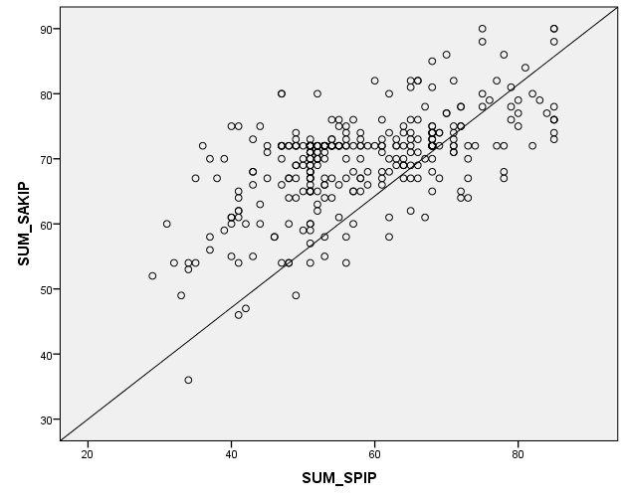
Figure 2
Linearity Test on SPIP Implementation and SAKIP Implementation
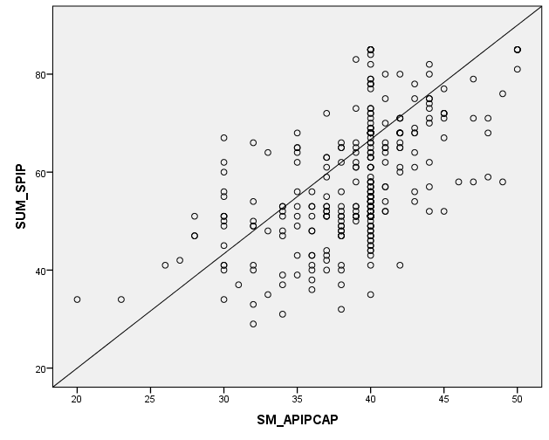
Figure 3
Linearity Test on SPIP Implementation and APIP Capability
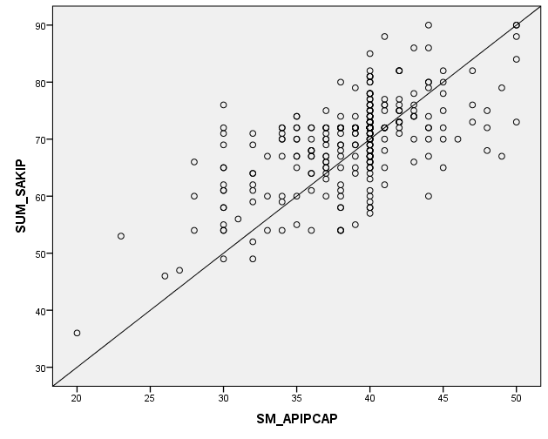
Figure 4
Linearity Test of SAKIP Implementation and APIP Capability

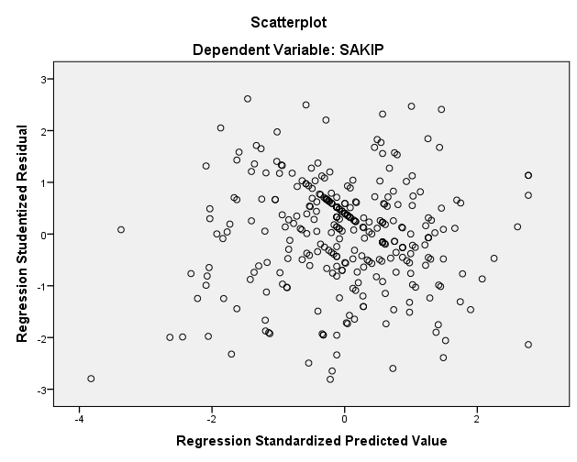
Figure 5
Heteroscedasticity Test

Table 6
Multicollinearity Test
Coefficients
Variable | Tolerance | VIF
SPIP Implementation | 0.700 | 1.428
APIP Capability | 0.700 | 1.428

Table 7
Coefficient of regression model 1
Model | T | Sig
SPIP Implementation | 13.052 | 0.000
Dependent Variable: SAKIP Implementation

Table 8
Model Summary of model 1
Variable | R square
SPIP Implementation | 0.345

Table 9
Coefficient of regression model 2
Variable | Sig
SPIP Implementation | 0.001
APIP Capability | 0.000
SPIP Implementation*APIP Capability | 0.017

Table 10
Model Summary of model 2
Variable | R Square
SPIP Implementation, APIP Capability, SPIP Implementation*APIP Capability | 0.498

