Exploring accounting control for cash revenue and disbursement in micro-enterprises

Nur’aini Rokhmania*, Nurul HU Dewi, Pepie Diptyana,
STIE Perbanas Surabaya, East Java, Indonesia
E-mail: nuraini@perbanas.ac.id

ARTICLE INFO |  | ABSTRACT
Article history:  Received 08 January 2020  Revised 22 September 2020  Accepted 24 September 2020  JEL Classification:  M41  Keywords.  Accounting procedures, Internal control, Bank, Cash transaction  DOI:  10.14414/tiar.v10i2.2036 |  | This study aims to describe the implementation of accounting procedures and internal control in micro-enterprises. The research data were obtained from source persons consisting of micro business owners 'LBB Surabaya' and 'Travel Pahlawan', employees, and customers. The data were analyzed using a descriptive qualitative. The results showed that the accounting records maintained were Cash Books that were matched with bank records. There have been no written accounting procedures and reconciliation between company’s cash records and bank books. Internal control was implemented in the form of good communication and values in holding trust. However, it is necessary to carry out reconciliation, transaction documentation, and document archiving well and minimize cash transactions to reduce the risk of fraud and increase the accuracy of accounting data.
 |  | ABSTRAK
 |  | Penelitian ini bertujuan untuk mendeskripsikan prosedur akuntansi yang diterapkan dan cara pengendalian internal yang dapat dilakukan oleh pengusaha mikro.Narasumber penelitian adalah pemilik usaha mikro ‘LBB Surabaya’ dan ‘Travel Pahlawan’, karyawannya, dan pengguna jasa perusahaan. Data dianalisis menggunakan metode penelitian kualitatif deskriptif. Hasil penelitian menunjukkan bahwa catatan akuntansi yang dimaintain adalah Buku Kas yang dicocokkan dengan catatan bank. Belum ada prosedur akuntansi secara tertulis, dan belum dilakukan rekonsiliasi antara catatan kas di perusahaan dengan buku bank. Pengendalian yang telah dilakukan adalah dalam bentuk komunikasi yang baik dan nilai-nilai memegang kepercayaan. Walaupun demikian, perlu dilakukan rekonsiliasi, dokumentasi transaksi dan pengarsipan dokumen dengan baik, serta meminimumkan transaksi tunai untuk mengurangi risiko fraud dan meningkatkan akurasi data akuntansi.

1. INTRODUCTION
Most micro, small, and medium enterprises (MSMEs) are companies owned by individuals or family businesses. The influence of the founders and owners on the company's operations, especially in small companies, is very strong (Lussier & Sonfield, 2015). This strong influence of the founders or owners on the company often results in mixed management of personal assets and company assets. According to Sari (2013), there is a tendency to use the company funds for the personal needs of the owner or founder of the company, and they also often treated company profits or income as their own money. The finding also proves that the concept of entity is not properly applied to micro, small, and medium enterprises (MSMEs).
According to Kurniawati et al. (2012), most micro and small enterprises cannot accurately state their operating profit in currency figures, but rather describe their business success in the form of adding tangible assets such as motorcycles, houses, or cars. Twenty-six (50.98%) respondents stated that their companies had been established for more than 10 years without good accounting procedures, but the company was still able to run (Kurniawati et al, 2012). According to Putra (2019), the level of employee education, company size, length of company standing, and level of accounting knowledge do not affect MSME's interest in utilizing good accounting procedures. This means that the accounting practices applied by MSMEs, which are related to the preparation of external financial statements, are still limited. This is caused by the full involvement of the business owner or they have not applied entity concept yet.
Entity concepts need to be applied to MSMEs and non-profit organizations to evaluate business performance. As long as there is no wealth separation between the entity's wealth and the owner's or manager's wealth, the success of a business will seem vague. The source of business success data owned by the company is only the history of business development in the form of non-financial data such as number of customers, age of business, average turnover, and average production costs. However, the existing non-financial data do not yet have an accounting flow that can document transactions objectively, so there are no precise figures that can describe the financial capabilities of the entity. The intervention of the owner who is always ready to disburse personal funds into the business, personal loans made by the owner for the smooth flow of cash flow of the entity, and the profit sharing can make the entity's financial performance blurred.
Although MSME entrepreneurs perceive that companies do not need financial reports, they actually have carried out accounting procedures for decision making by the owners. Based on a survey of 51 MSMEs in Solo, it is known that MSMEs that record Cash In are 78.43%, MSMEs that record Cash Out are 78.43%, MSMEs that record Sales are 66.67%, MSMEs that record Purchases are 64.7%, MSMEs that record Inventories are 52.94%), MSMEs that record are Costs are 60.78%, and MSMEs that record Salary are 47.06%. Meanwhile the MSMEs that make Sales Report are 66.67%, MSMEs that make Purchase Report are 52.94%), MSMEs that make Inventory Report are 45.10%, and MSMEs that make Salary Report are 41.18%.
According to the survey, the application of accounting procedures is very limited because entrepreneurs feel that the accounting procedures are only needed for companies that are not self-managed by their owners (Kurniawati et al, 2012). Ibarra & Velasco (2015) conducted a survey of 470 MSMEs in Metro Manila and Quezon Province, Philippines. The results show that the accounting practices commonly applied by MSMEs are described in the form of determining bad debt estimates, depreciation methods, and estimated net receivables.
Accounting, which is interpreted as a function and as a control (Petro, 2016), presents financial information in accordance with generally accepted principles. The presentation of such information can only be accurate if it is carried out based on procedures that ensure that the data used is accurate. Therefore, accounting is not only about the method of calculating and compiling information but also about the quality of the data source.
The accuracy of data can be determined by transaction and event documentation. Accounting documentation is necessary to control cash and company records (Ibarra & Velasco, 2015). Respondents of a survey conducted by Ibarra & Velasco (2015) state that they always maintain a bank account and routinely deposit cash to banks every day or on the next working day to prevent misuse of cash. The control practices that many MSMEs do, in addition to maintaining a bank account, are recording expenses on a daily basis and preparing a budget. In addition, the use of business documents is a significant accounting practice in controlling the accuracy of numbers. The use of computers is the application of data control which is the least used by MSMEs (Ibarra & Velasco, 2015; Kurniawan & Diptyana, 2011).
According to the previous studies, the micro, small, and medium enterprises (MSMEs) have not compiled financial reports in accordance with Indonesian Financial Accounting Standard actually have made efforts to carry out accounting procedures (Kurniawati et al, 2012; Ibarra & Velasco, 2015; Ningtyas, 2017). However, it is still limited regarding research on accounting procedures and accounting data control practices in particular income and cash receipts. This study contributes to further researchers and to the community in the form of an overview of the implementation of accounting procedures and internal control in micro enterprises.
Therefore, the research question raised is “How is the implementation of accounting procedures and internal control in micro enterprises?

2. THEORETICAL FRAMEWORK
Entity Theory and Entity Concept
These theories and concepts lead to an understanding of what should be disclosed in financial statements as well as what accounts that influence investors' decisions. The Entity Theory was proposed by Patton in 1922 (Clark, 1993). According to the entity theory, both creditors and investors deposit their capital in the hope of getting a return. The source of funding does not affect and is not affected by the company's ongoing operations. Patton states that the company's capital structure is not relevant to company performance based on two basic assumptions: (1) investment decisions and funding decisions are independent, and (2) the value of the company is not influenced by the types of capital in the capital structure. Furthermore, Paton argues that the capital source does not affect the performance of the company. If debt becomes a stock substitution, the cost of production factors will remain the same. Operating profit is also not affected by leverage. As a result, the company's leverage ratio has no impact on the company's value, so that the leverage ratio is declared irrelevant as information when making decisions by investors. Advocates of Entity Theory state that the capital structure that distinguishes Debt from Capital is irrelevant to investment decisions. The point is that the two things are Equity. In which both will cause costs for the company or generate returns for the giver but has nothing to do with the company's operations. Therefore, the accounting equation that Patton argues is Asset = Equity (Clark, 1993). This equation describes the form of double entry bookkeeping (DEB).
DEB theory is built based on entity concept. The Entity Concept or Economic Entity Concept states that a company is considered an economic entity or a business that is separate from its owner. As a result, the relationship between the owner and his company is treated like a transaction between two separate parties. If not separated, the owner will have difficulty determining the company's performance, whether the company is profit or loss, cash flow difficulties or not, and so on.

Accounting Control
Accounting control is a process that ensures the safety of accounting data and the achievement of accounting objectives by presenting quality financial information for external and internal parties. The accounting process includes transactions, events, and circumstances that have economic implications for the entity. Recording based on verified evidence, double entry bookkeeping, and steps in the accounting cycle show that accounting is a systematic and controlled process of presenting information. Petro (2016) concludes that accounting control is not only carried out by internal and external auditors, but it is also carried out by comparing, reconciling, and harmonizing data while analyzing and synthesizing accounting data in the accounting function itself.
Accounting control is part of the implementation of internal controls that cannot be separated. Internal control is a process implemented by certain entities to obtain reasonable assurance for achieving the control objectives such as: (1) protecting assets from unauthorized use, transfer or neglect of assets, (2) maintaining records to always be complete and detailed in order to produce accurate and honest asset reports, (3) providing reliable and accurate information, (4) preparing financial reports in accordance with criteria established by management, (5) encouraging and improving operational efficiency, (6) encouraging compliance with managerial policies, (7) ensuring the company's operational compliance with applicable laws and regulations, and (8) ensuring that the objectives set by the company will be achieved. To achieve these goals, COSO develops five components of internal control, consisting of: (1) Control Environment, (2) Risk Assessment, (3) Control Procedures, (4) Monitoring, and (5) Information and Communication (Romney & Steinbart, 2018). The components of control environment include the existence of integrity and ethical values, commitment to competencies, audit committees, organizational structures – organization - responsibilities, human resource policies, and philosophy & management style.

Previous Research
The results of previous studies show that many MSMEs have not made financial statements (Kurniawati et al, 2012; Ibarra & Velasco, 2015; Putra, 2019), because the application of Accounting Standards is still limited (Ningtyas, 2017). This can be caused by the lack of application of entity concept (Sari, 2013; Sembiring & Elisabeth, 2018). The entrepreneurs feel that the financial statements are only used for the owner or internal decision purposes only.
Although they do not prepare a complete financial statement, entrepreneurs have a way to find out the performance and maintain their business cash flow. This shows that the actual control and recording activities have been carried out by entrepreneurs or NGO managers. The forms of accounting control that is always and mostly carried out by MSMEs in the Philippines are: recording spending transactions daily, preparing a budget, and maintaining a bank account (Ibarra & Velasco, 2015).
The accounting practices done by MSMEs are still very simple and are carried out as a form of controlling assets in the MSMEs. According to Ibarra & Velasco (2015), in the Philippines, accounting practices applied by MSMEs include accounting methods (cash basis or accrual basis), the use of the method of estimating and recording the allowance for receivable losses and determining the net value of receivables that can be collected, depreciation method and business documents used as the basis for financial records, and recording of payment methods (installments or cash). Meanwhile, based on research by Kurniawati et al (2012), MSMEs in Salatiga apply accounting practices by maintaining transaction records. The most common recording is the recording of Cash In and Cash Out (78.43% of respondents). Transaction records other than Cash In and Cash Out are also conducted for Sales, Purchases, Costs, and Inventory transactions. Most MSMEs do not record Salary Transactions in their books.
The performance indicators which are widely used by entrepreneurs are income and expenditure figures. MSME entrepreneurs have confidence that the businesses they run are not loss-making and are worth maintaining. Trust is certainly not based on intuition alone. The entrepreneurs also have a way to collect data to measure the performance of their businesses. Entrepreneurs, consciously or unconsciously, have carried out a system of recording, controlling and collecting income and expenditure data. Patton states that bookkeeping and accounting are not identical but the quality of accounting depends on the quality of bookkeeping (Warsono, 2019). The quality of bookkeeping determines the company's performance and accountability data.

3. RESEARCH METHOD
This study tries to reveal the internal control implementation through accounting system of cash revenue and disbursement in micro enterprises. This study is a case study with qualitative method. Data were collected through interview and direct observation. The research was carried out in 'LBB Surabaya' and 'Travel Pahlawan'. Data collection was carried out from July 2019 to September 2019. Interviews were conducted with prior agreement with the interviewees. Places of the interviews were outside and inside the resource persons' office. The researchers recorded and wrote the results of the interview. The researchers validated the results of the questions with triangulation, which is matching among the statements of the resource persons such as business owners, employees, and service users, and looking at documentary evidence. The interpretation was based on the discovery of the same keywords stated by the resource persons.

4. DATA ANALYSIS AND DISCUSSION
This study collected information from two micro enterprises: ‘LBB Surabaya’ and ‘Travel Pahlawan’. ‘LBB Surabaya’ was founded in 2015 by Mr. Aryo, who at that time was still a college student and as private tutor. 'LBB Surabaya' initially only focused on serving learning courses for elementary to high school students. After five years and observing its developments every year, this LBB then added its educational services to foreign language courses and abacus. 'LBB Surabaya' which is headquartered in the city of Surabaya has opened branch offices in Malang and Sidoarjo. And up to now 'LBB Surabaya' has employed approximately 200 tutors. Activity and communication between 'LBB Surabaya' and its service users are established on Facebook and Instagram social media. 'Travel Pahlawan' was founded and owned by Mr. Tri and employs five permanent employees. 'Travel Pahlawan' was established in 2015. Until now, it has been serving travel services, transportation procurement, accommodation, and documentation when traveling activities of various corporate clients, as well as the community.

Implementation of Accounting Control
The discussion of accounting controls in this study is divided into three parts: (1) control environment, (2) accounting procedures, and (3) risk and control. The component of control environment that cannot be observed is the existence of audit committee. In micro companies, in general, all control and operations are still fully handled by the owner and there is no involvement of an audit committee. Debt transactions or business loans are also still in the owner's personal name. Therefore, the companies do not need the existence of an audit committee.

Control Environment
Control environment describes the situation in the organization that can directly create control over assets, records, and organizational performance. Control environment includes integrity and ethical values in the company, employee and company commitment to competence in accordance with their position or field, organizational structure and responsibilities, and ongoing human resource policies.
The value adopted by the organization is one important component in the control environment. Ethical values and integrity are created and shaped in daily activities. Based on interviews, the value of trust is a key to business management. Each member of the organization must be able to be a trusted by service users and coworkers.
"Trust is the key. If we lose the trust of other parties, we will not be able to develop. So the most important thing is to maintain that trust" (Mr. Aryo, owner of 'LBB Surabaya')
"In the business dealing with services, we must be trustworthy. All employees here must be trusted by the service users. We work in teams and must also be able to maintain mutual trust so that everything can run smoothly.” (Mr. Tri, owner of ‘Travel Pahlawan ’)
One of the 'LBB Surabaya' tutors also says that if there is a problem, he can openly convey the problem to the owner at any time, not having to wait for a meeting with the owner. The employees of 'Travel Pahlawan' also state that all issues can be discussed directly with the owner. For employees, open communication is the basis for building trust in one another.
From the perspective of service users, trust is also the foundation of this business.
"My child has been studying at ‘LBB Surabaya’ for more than three years. There is no problem with his tutors. If they cannot come, there must be a change of schedule. His tutors are so smart that my child never feels bored. The tutors have a high commitment and can be trusted. The payment process is very easy, just transfer. And I always get proof of payment." (Ms. Rachma, service user of 'LBB Surabaya')
"The hospitality, thoroughness, and patience provided by the Travel crew make the activities more enjoyable" (Mrs. Wina, service user of ‘Travel Pahlawan')
According to the informants, the term “trustworthy” means being able to fulfill promises, or behave according to what is said. In the 'LBB Surabaya' business, parents entrust their children to get lessons in accordance with the material and the time agreed upon in advance. Therefore, 'LBB Surabaya' provides learning materials, communicates the learning outcomes of its students, confirms when there is a change in schedule, and responds to complaints and suggestions from customers. The value of trust is believed to increase the number of students, branch offices, and tutors. Like ‘LBB Surabaya’, 'Travel Pahlawan' also conducts a preliminary study of prices and routes before agreeing with the travel cooperation and providing services according to the agreement, with the friendly crew.
An observation in the control environment is the form of an organizational structure and it shows that there is no written organizational structure. However, there is already a division of tasks and authority. In ‘LBB Surabaya’ and ‘Travel Pahlawan’, both have an administration section that manages correspondence, student registration or cooperation contracts, and operational sections responsible for services, and deal directly with service users. The accounting work is still carried out by the owner, with the help of the Administration Section as the keeper of the form. The owner determines the competency criteria of the prospective employee when hiring. The administration section is at least from Vocational School graduate. The tutors working in 'LBB Surabaya' are also selected based on their relevant knowledge. For example, junior high school physics instructors are recruited from the engineering faculty graduates, or final-year engineering faculty students, or physics education. The tour guides in 'Travel Pahlawa’ are recruited from the tourism high school graduates. Meanwhile, the role of accounting is still handled by the owner.
Both of these micro-businesses already have a human resource policy that is stated in the work agreement and is submitted at the time of recruitment. In 'LBB Surabaya', there is a written and clear policy that one tutor has the right to handle 4-5 students and the location of students close to the location of the tutor. If the tutor is unable to teach, he must give a report so that he can be replaced by another tutor, or must report a change in schedule. There are policies regarding the employee performance appraisal and reward and punishment standards in 'LBB Surabaya'. So, if an employee can exceed the performance target, he will get a bonus. Good communication among tutors, employees, and management (owner) is intimate, good and open. The owner accepts suggestions and criticisms from employees. If there is a particular problem, the owner also asks for opinions from employees and his tutors as consideration.
"If there is no operating standard, it is difficult to handle more than 200 tutors and employees at the branches. Alhamdulillah, we already have an operating standard for tutors" (Mr. Aryo, owner of 'LBB Surabaya')
Meanwhile, in 'Travel Pahlawan', HR policies are still not written, even though they have become a mutual agreement. The number of employees working in ‘Travel Pahlawan’ is 5 permanent employees, and 2-3 freelancers for each large event and if additional personnel are needed. Employee performance evaluations are conducted every month, in a relaxed and serious way. Communication is established through face to face and WhatsApp media. The owner also knows which employees directly involved in each event, including who the freelancers are.
The control environment is a fundamental component of the principle of internal control according to COSO (Romney & Steinbart, 2018). The core control components are actually the people within the organization itself, including integrity, discipline, ethical values, competencies and the environment that surrounds them. In MSMEs, especially in 'LBB Surabaya' and 'Travel Pahlawan', openness, sense of responsibility, and awareness to serve one another, both to the leaders and to the fellow colleagues, including to provide service to users and to maintain trust in each other have become the basis for controlling the running of their business.
Accounting Procedure
According to the informants, the owner of ‘LBB Surabaya and the owner of ‘Travel Pahlawan’, have no written accounting procedures in their businesses. The financial records end only on the cash in and cash out statements which are evaluated monthly by the owner. Recording is carried out on a cash basis. Income is recognized by the owner based on cash received. The owner has a full role in the cash out decision and controls the cash flow. This supports the results of research conducted by Lussier & Sonfield (2015) that in micro companies, the owner has more roles in the company.
Nevertheless, both companies have a record of accounts receivable that is recapitulated at the end of each month as an evaluation of uncollectible receivables and predictions of the following month's cash income. Until this research was made, 'LBB Surabaya' and 'Travel Pahlawan' had never been experiencing bad debts for more than 2 months. The value of receivables was less than 1% of total cash income. In 'LBB Surabaya', payment of guidance services was carried out at the end of the month, where the payment deadline was until the 5th of the following month. The 'LBB Surabaya' management contacted the customer to remind the payment schedule. In ‘Travel Pahlawan’ there was a down payment as a sign of being a service user, and was repaid during the trip. It seemed that cash flow was quite safe and definitely accepted. However, 'Travel Pahlawan' had to conduct research on the price of transportation and accommodation facilities quickly and accurately, and confirmed travel participants so that they did not suffer losses due to the agreed price difference with the price at the time of implementation.
"The most important is that before the deal, there is certainty of data related to the price for bus rental, the price of tickets, lodging, and the number of tour participants. We got an experience, where the prices had been agreed, but it turned out that the accommodation costs went up. Inevitably we had to bear losses. It is impossible for us to suddenly increase the price agreed upon by the customer." Said Mr. Tri, the owner of 'Travel Pahlawan').
The accounting procedures for cash revenue and cash disbursement in 'LBB Surabaya' are shown in Figure 1 and Figure 2, while the accounting procedures for cash revenue and cash disbursement in 'Travel Pahlawan’ are shown in Figure 3 and Figure 4.
In Figure 1, it can be seen that the administration section submits the registration form for the registration transaction, receives cash on registration fees and monthly course fees, or receives proof of transfer from students. The administration section records these payments in the Student Register. The Student Register book functions like an Accounts Receivable Book that records the balance of the course fee bill. After receiving money or proof of transfer, the administration section makes a double receipt. The original sheet is handed over to students, directly or entrusted to the tutor, and the file is archived together with proof of transfer. At the end of each month the administration section recapitulates the total cash receipts and transfers and submits the recapitulation file to the owner to be checked. The owner matches cash incomes and transfers from bank records and then records them as Cash Revenues into the Cash Book.
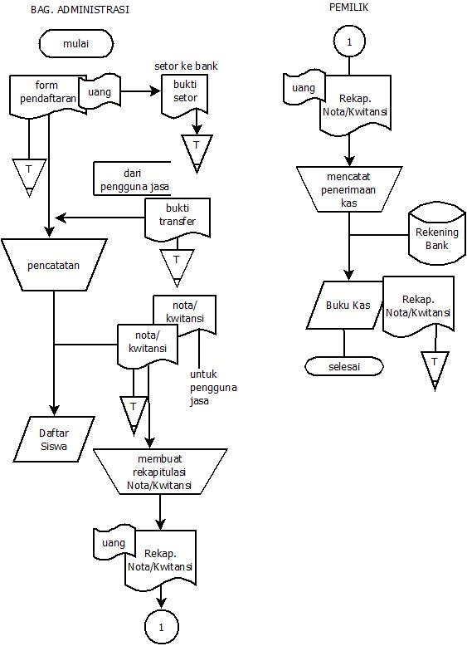
Figure 1. Accounting Procedure for Cash Revenue in 'LBB Surabaya'

Cash disbursement transactions often occur in tutor salary payments. Therefore, the accounting procedure described is the payment of tutor salary. For the payment of other costs, such as contributions, is made by the formation of petty cash entrusted to the administration section. The formation of petty cash procedures is the same as the expenditure of salary costs, but the value of petty cash is directly determined by the owner. In Figure 2, the administration section makes a recapitulation of salary costs based on the payroll and the attendance list. The salary bill recapitulation is conveyed to the owner. Furthermore, the owner pays the tutor salary by way of transfer, and saves the proof of transfer as proof of payment, and then records it in the Cash Book. Therefore, in the Cash Book, cash revenues and disbursements are recorded each month.
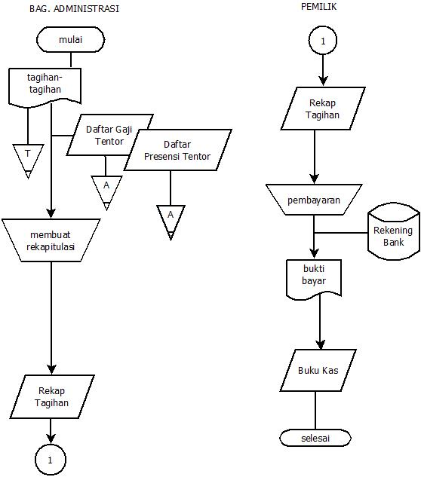
Figure 2. Procedure for Cash Disbursement (Salary Costs) in ‘LBB Surabaya’

In Figure 3, it can be seen that the income recording is based on a Cooperation Contract or a deal. When the Service Order Letter is received, the marketing section must ensure the pricing and costs that he makes. If the travel service work is continued, a Cooperation Contract is issued. The service user pays the down payment and the marketing section makes the receipt. The marketing section communicates to the owner that there is a demand for procurement of services. The owner can receive payment via transfer or cash. The owner, who also serves as the finance section, then makes a double receipt, the original sheet for service users and the copy sheet as an archived file together with the initial invoice that refers to the Cooperation Contract. At the end of the month, the owner recapitulates archives and bank records, and then records the correct value of Cash Revenue in the Cash Book.
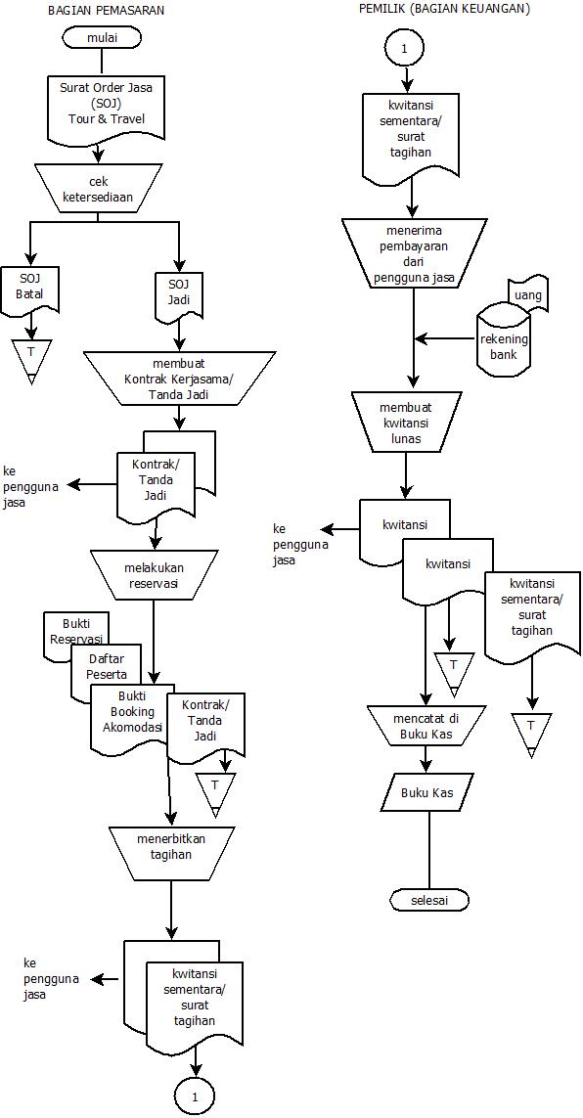
Figure 3. Accounting Procedure for Cash Revenue in 'Travel Pahlawan'

Accounting for cash disbursement in 'Travel Pahlawan' is presented in Figure 4. In this figure the Payroll is a source of salary payment data. This payroll contains the amount of employee salary and freelance employee wages. The administration section which also serves as the personnel section makes a dual salary slip which is submitted to the owner as a bill to pay salaries. Furthermore, the owner pays salary through a transfer for employees and cash for freelancers. The 1st sheet salary slip is given to the salary recipient and the 2nd sheet is signed by the payee and then archived by the owner. After the payment of the salary, the owner records cash disbursements for salary in the Cash Book.
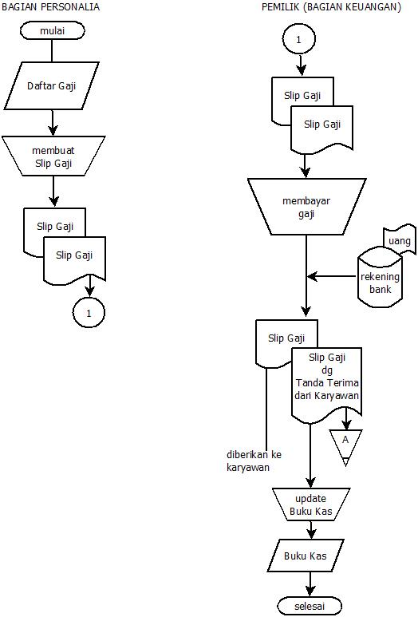
Figure 4. Accounting Procedure for Cash Disbursement in 'Travel Pahlawan'

Based on observations and results of the interviews, it is known that the owner is still fully involved in all transactions. The bank account used is an account in the owner's personal name, there is no c / q or copy of the company name in the bank account name. Owners of 'LBB Surabaya' and 'Travel Pahlawan' use this bank account as a form of cash control. This supports the results of research conducted by Ibarra & Velasco (2015) and Kurniawati et al (2012).
All cash in and out decisions as income and expenses are in the full authority of the owner. For small nominal expenses, the owner forms a Petty Cash entrusted to the Administration Section. The Administration Section is responsible for the use of the Petty Cash.
The accounting activities carried out are still limited to the Cash Book controlled by the owner, and the Accounts Receivable Book is handled by the administration section. In ‘LBB Surabaya’, the Accounts Receivable Record is on the Student List which describes the list of attendees, bills, and cash in from students. The findings in the form of the Accounts Receivable Book supports the results of the research conducted by Ibarra & Velasco (2015) that the existence of the practice of accounting procedures in MSMEs is the implementation of the Accounts Receivable Book. Cooperation Contracts that have not been accompanied by a receipt indicate that the work is in progress or unpaid.
In file control practices, 'LBB Surabaya' has included a numbered form on the Receipt for Students. However, in 'Travel Pahlawan' there is no printed number for the identity of the Cooperation Contract and the Receipt, so it takes time to trace whether the payment amount is in accordance with what was agreed upon.

Risk and Control
According to the COSO principle, organizations must be able to identify, analyze, and manage risk. Risk management is a dynamic process that takes into account the external and internal environment of the company (Romney & Steinbart, 2018). Risk management is done by considering the occurrence of fraud, identifying environmental changes, and determining the clarity of organizational goals in order to identify risks. After the risks are identified, the company needs to determine the form of control.
In 'LBB Surabaya' and 'Travel pahlawan', the recording of cash book (cash in and out) is fully controlled by the owner, and the owner is also involved in the company's operations, so the owner relies more often on bank account data. Cash book is updated late. There is no reconciliation process to match data or files with financial records. As long as there is a positive balance in the bank account and can still pay fees, the owner assumes that his business can still survive, not lose money. And the owner feels that his business is still smooth. However, to answer the question how much is total cash income up to a certain point in time, the owner can name the nominal range but having difficulties in finding the exact amount in IDR. Likewise, with the total cost, the owner more easily describes the profit and loss each month in the form of an estimate of the average percentage or whether or not the funds are available to pay salaries. The risk means that the accounting data for profit and loss is less accurate. Companies will experience difficulties if they want to prepare financial reports in accordance with Financial Accounting Standards.
In 'Travel Pahlawan', the Cooperation Contract and the Receipt are still not numbered, so there is a risk of inaccurate accounting numbers on revenue, whether recorded based on the money received or in accordance with the cooperation contract. If there is a difference in value between the money received and the Work Contract, the difference has not been recorded.
Since finances and records are fully controlled by the owner, the Accounting policy does not yet exist in writing. The owner wants one day to have a special staff for accounting, but for now he feels that he still does not need to recruit or does not need to hand over financial management and records to anyone else. However, for the owner, this is not yet a problem that interferes with the company's operations because the financial statements are still needed for the owner only, not for external parties. This finding supports the research conducted by Kurniawati et al, (2012). As long as the policy procedure is unclear and the financial documentation that supports the availability of data sources is still not compiled well, the accounting tools based on computer technology cannot yet be directly used to prepare financial reports (Kurniawan & Diptyana, 2011; Putra, 2019).
Although a bank account has been used, the use of the bank account is not yet optimum. Cash receipts from service users are still entrusted to employees. In 'LBB Surabaya', there are still students who deposit money in the administration section. In 'Travel Pahlawan’, the sales section also accept entrusted payments. Since the owner keeps maintaining consistency of communication with employees and is directly involved in day-to-day operations, this is not a problem. The risk of entrusted money is lapping or fraud. If the risk occurs, the owner will act decisively. The value of openness and holding the trust applied in 'LBB Surabaya' and 'Travel Heroes' is the main control tool for this risk. Nevertheless, the owner states that he has already had a plan to anticipate the risk, while at the same time making easy access for his service users.
The single entry method applied by 'LBB Surabaya' and 'Travel Heroes' leads to the risk of inaccurate accounting data because there is still unrecorded cash-in-transit. Cash-in-transit can occur because there is money from service users that is entrusted to employees and has not been deposited, or checks that have not been cashed. This risk can be reduced by making a reconciliation report. Cash account reconciliation is one form of effective internal cash control (Fatmawati & Sutarti, 2015; Mulyadi, 2016). Owners who rely on bank records as cash data need to reconcile to show the exact cash value at a certain date. If the company wants to develop and apply financial accounting standards, the bank account should not be mixed with the personal expenditure of the owner. If there is a personal cash transaction using company’s bank account, it also needs to be taken into account in reconciliation.

5. CONCLUSION, IMPLICATION, SUGGESTION, AND LIMITATION
Based on the results of interviews and observations of evidence, it can be concluded as to the following. First, in micro-business services sector ("LBB Surabaya" and "Travel Pahlawan"), internal control is entirely carried out by the owner or manager. The concept of entity does not appear to be fully implemented. Second, a bank account has been used, but as a means of cash control only. There are efforts to minimize cash receipts in cash. Third, there has been no reconciliation that can show the exact figures of cash revenue and disbursement. There are entrusted funds and/ or the value that is not the same between the bill and the sale price agreement, and the cash received has not been recorded. Fourth, because the owner still has a dominant role in the company’s day-to-day operations, many policies have not been in written. There is no written account and petty cash policy, so it is prone to inconsistencies in account writing or categorization. Fifth, the availability of data archiving and storage needs to be re-evaluated so that the company has sufficient data to conduct reconciliation. Sixth, although accounting data are inaccurate, employers state that they can still use existing data to conduct their business. During this time their business is quite smooth, by instilling the value of trust and good communication among the owners, as the holder of control, his employees, and service users.
The implication is that such an accounting control can be difficult if the company will prepare financial statements based on the applicable Financial Accounting Standard in Indonesia. The limitation of this study includes the limited time for interviews and observations and some documents that cannot be presented. Therefore, it is recommended that further researchers deepen the implementation of internal control risk reduction and the documentation in micro and small companies.

REFERENCES
Clark, M. W. (1993) ‘Entity Theory, Modern Capital Structure Theory, and The Distinction Between Debt and Equity.’, Accounting Horizons, 7(3), pp. 14–31.
Fatmawati, M. P. G. and Sutarti (2015) ‘Pengaruh Sistem Akuntansi Kas Kecil dan Rekonsiliasi Bank terhadap Efektivitas Pengendalian Kas’. Available at: ttps://www.researchgate.net/publication/326998487.
Ibarra, V. C. and Velasco, R. M. (2015) ‘Accounting Knowledge, Practices, and Controls of Micro, Small and Medium Enterprises: Evidence from the Philippines’, Accounting & Taxation, 7(2), pp. 83–96.
Kurniawan, R. and Diptyana, P. (2011) ‘Telaah Pemanfaatan Software Akuntansi Oleh Usaha Kecil dan Menengah’, The Indonesian Accounting Review, 1(2), pp. 107–116. doi: 10.14414/tiar.v1i02.324.
Kurniawati, E. P., Nugroho, P. I. and Arifin, C. (2012) ‘Penerapan Akuntansi pada Usaha Mikro Kecil dan Menengah (UMKM)’, Jurnal Manajemen dan Keuangan, 10(2), pp. 1–10.
Lussier, R. N. and Sonfield, M. C. (2015) ‘“Micro” versus “Small” Family Businesses: A Multinational Analysis’, Journal of Small Business and Enterprise Development, 22(3), pp. 380–396. doi: 10.1108/JSBED-02-2015-0029.
Mulyadi (2016) Sistem Akuntansi. 4th edition. Jakarta: Salemba Empat.
Ningtyas, J. D. (2017) ‘Penyusunan Laporan Keuangan UMKM Berdasarkan SAK Entitas Mikro Kecil dan Menengah (SAK EMKM): Studi Kasus di UMKM Bintang Malam Pekalongan’, Owner : Riset dan Jurnal Akuntansi, 1(2), pp. 11–17. doi: doi.org/10.33395/owner.
Petro, K. (2016) ‘Difference Between Function and Procedures in Accounting’, Institute of Accounting, Control and Analysis in The Globalization Circumstances, (1), pp. 15–21.
Putra, Y. M. (2019) ‘Analysis of Factors Affecting the Interests of SMEs Using Accounting Applications’, Journal of Economics and Business, 2(3), pp. 818–826. doi: 10.31014/aior.1992.02.03.129.
Romney, M. B. and Steinbart, P. J. (2018) Accounting Information Systems. 14th edition. Harlow, England: Pearson.
Sari, D. P. (2013) ‘Telisik Perlakuan Teori Entitas dalam Usaha Mikro, Kecil dan Menengah (UMKM)’, Jurnal Akuntansi Multiparadigma, 4(2), pp. 188–197. doi: 10.18202/jamal.2013.08.7192.
Warsono, S. (2019) ‘Revisitasi Teori Double Entry Bookkeeping’, in Hartono, J. (ed.) Kajian Topik-Topik Mutakhir dan Agenda Riset Ke Depan. Yogyakarta, Indonesia: Penerbit Andi, pp. 91–117.

