Development of mandatory & voluntary instruments of sustainability reporting (SR) according to carrots & sticks 2006 - 2016

Ririn Breliastiti
Universitas Bunda Mulia, Banten, Indonesia
Email: rbreliastiti@bundamulia.ac.id

ARTICLE INFO |  | ABSTRACT
Article history:  Received 31 October 2019  Revised 17 February 2020  Accepted 20 February 2020  JEL Classification:  Q56  Key words:  Sustainability Reporting, Carrots & Sticks, mandatory and voluntary instrument  DOI:  10.14414/tiar.v10i1.1931 |  | Sustainability Reporting (SR) has become the main report of the world's leading companies. In 2005, it was found that more than 250 top companies listed on the Fortune 500 had prepared SR separately from the Annual Report in which the number in each country varies. In the developed countries, awareness to compile and issue SR is supported by government regulations so that SR becomes mandatory. Yet, in developing countries, SR is still voluntary because there is still no regulation requiring the companies to compile and issue SR. This research aims to find out the development of the mandatory and voluntary instruments related to SR. It is a literature review done using instruments such as a tabulation containing the development of the mandatory and voluntary instruments (government policy). Enthusiasm for the application of SR and commitment, and efforts to achieve transparency and accountability all have increased. Countries with interest in SR have a significant development: 19 countries in 2006, 32 countries in 2010, 45 countries and regions in 2013, and 71 countries and regions in 2016. Indonesia, especially, has its SR regulations that have grown from 180 in 2013 to 400 in 2016, with government regulations dominating 80% of all regulations. Mandatory instruments dominate more than voluntary instruments. The application of SR 30% is for large companies listed on the stock exchange. SR reporting by public companies has covered all sectors on the stock exchange. All were greatly influenced by the role of the government encouraging the companies to disclose information about sustainability in their annual reports. Social reporting instruments show a faster development than environmental reporting instruments.
 |  | ABSTRAK
 |  | Sustainability Reporting (SR) telah menjadi laporan utama perusahaan-perusahaan terkemuka dunia. Pada 2005, ditemukan bahwa lebih dari 250 perusahaan top yang terdaftar di Fortune 500 telah menyiapkan SR secara terpisah dari Laporan Tahunan di mana jumlah di setiap negara bervariasi. Di negara maju, kesadaran untuk menyusun dan mengeluarkan SR didukung oleh peraturan pemerintah sehingga SR menjadi wajib. Namun, di negara-negara berkembang, SR masih bersifat sukarela karena masih belum ada peraturan yang mewajibkan perusahaan untuk menyusun dan menerbitkan SR. Penelitian ini bertujuan untuk mengetahui pengembangan instrumen wajib dan sukarela terkait dengan SR. Ini adalah tinjauan literatur yang dilakukan menggunakan instrumen seperti tabulasi yang berisi pengembangan instrumen wajib dan sukarela (kebijakan pemerintah). Antusiasme untuk penerapan SR dan komitmen, dan upaya untuk mencapai transparansi dan akuntabilitas semua telah meningkat. Negara-negara yang berkepentingan dengan SR memiliki perkembangan yang signifikan: 19 negara pada 2006, 32 negara pada 2010, 45 negara dan wilayah pada 2013, dan 71 negara dan wilayah pada 2016. Indonesia, khususnya, memiliki peraturan SR yang tumbuh dari 180 pada 2013 hingga 400 pada 2016, dengan peraturan pemerintah mendominasi 80% dari semua peraturan. Instrumen wajib mendominasi lebih dari instrumen sukarela. Penerapan SR 30% adalah untuk perusahaan besar yang terdaftar di bursa saham. Pelaporan SR oleh perusahaan publik telah mencakup semua sektor di bursa saham. Semua sangat dipengaruhi oleh peran pemerintah mendorong perusahaan untuk mengungkapkan informasi tentang keberlanjutan dalam laporan tahunan mereka. Instrumen pelaporan sosial menunjukkan perkembangan yang lebih cepat daripada instrumen pelaporan lingkungan

1. INTRODUCTION
Sustainability Reporting has become one of the main reports of the world's leading companies. According to an international survey conducted by KPMG on Corporate Responsibility Reporting in 2005, it was found that more than half, or 250 top companies listed on the Fortune 500 compiled the Sustainability Report (SR) separately from the Annual Report.
Carrots & Sticks report, compiled and published by KPMG, United Nations Environment Program, Unit for Corporate Governance in Africa & The Global Reporting Initiatives, provided an overview of the development of Mandatory & Voluntary instruments in the application of Sustainability Reporting (SR) in various countries throughout the world in the last ten years from 2006 to 2016.
Sustainable Development Goals (SDGs) have been declared by world country leaders since October 21, 2015 as a joint development ambition until 2030 (Panuluh and Fitri, 2016). Agenda 2030 consists of 17 Sustainable Development Goals or Global Goals as policy and funding guidance. In addition, on July 4, 2017, the President of the Republic of Indonesia also signed Presidential Regulation No. 59 of 2017 concerning the Implementation of Achieving Sustainable Development Goals. The Presidential Regulation was intended as a follow up of the agreement in Transforming Our World: The 2030 Agenda for Sustainable Development to end poverty, improve public health, promote education, and fight climate change (Presidential Regulation of the Republic of Indonesia, 2017).
In Indonesia, the number of SRs compiled by companies is still very limited. Based on the number of participants in the Indonesia Sustainability Report Award (ISRA), it shows the level of the companies‘ awareness and concern to report on their environmental performance. For SR in 2014 (ISRA 2015 participants), there were 37 participating companies, while For SR in 2015 (ISRA 2016 participants), there were 55 participating companies (National Center for Sustainability Reporting, 2015, 2016). Based on the description above, this study aims to determine the development of mandatory and voluntary instruments (government policies) related to SR in the world.

2. THEORETICAL BASIS AND EMPIRICAL STUDY
Definition of Sustainability
Sustainability can be briefly defined as doing what we can today, and preserving the environment for future generations. There are three components of sustainability: environment, equity, and economy (Brinkmann, 2016). Environment focuses on the efforts to preserve and protect the environment. Equity focuses on ensuring that there is fairness in decision making, when we are ahead, in the middle, and as we are moving forward into the future. The economic component of sustainability focuses on the fact that we need to ensure that livelihoods remain protected but while still trying to protect the environment for future generations (Brinkmann, 2016). According to Rankin et al. (2012), research in the field of sustainability is a contemporary research field in Accounting.

History of Sustainability Report (SR)
Corporate sustainability has been the subject of research interest in social science since the mid-1900s. Sustainability reporting developed in the mid-1990s as a means for business organizations to manage and balance their productive efforts with the environment and surrounding communities (Deegan, 2002). The concept and essence of sustainability were popularized by the Brundtland Report publication in 1987, with the title "Our Common Future". In this report, sustainability was defined as "the ability to meet the needs of the present generation without sacrificing the ability of future generations to meet their own needs".
The Rio de Janeiro Conference on Environment and Development in 1992 played a major role in promoting the idea that corporate sustainability was the result of three pillars: economic growth, ecological balance, and social responsibility. Furthermore, the United Nations Global Compact (UNGC) was established in 2000 by UN agencies, governments and civil society groups, to guide business organizations to harmonize their operations and strategies to follow four principles of sustainability: (1) Universal declaration of human rights; (2) Declaration of the basic principles of international labor organizations and rights at work; (3) Rio's Declaration on the environment and development; and (4) UN Convention against corruption. Christofi et al. (2012).

Previous Research

Table 1
Previous Research Results in the Field of Sustainability Reporting
No | Researcher and Year | Country | Research Objectives
1 | Amanpreet Kaur, Sumit K. Lodhia, (2014) | Australia | To describe the level of disclosure and involvement of stakeholder in sustainability reporting in the local council in Australia.
2 | Amber Bellringer, Amanda Ball, Russell Craig, (2011) | New Zealand | To describe comparative insights on sustainability reporting by local governments.
3 | Amina Buallay, (2018) | European countries | To reveiw the adoption of sustainability reporting by companies around the world regarding transparency on environmental, social and governance (ESG) issues.
4 | Aparna Bhatia, Siya Tuli, (2017) | India | To test the relationship between sustainability reporting by companies and company-specific attributes.
5 | Ben Marx, Vanessa van Dyk, (2011) | South Africa | To provide an overview of sustainability reporting and its guarantees in South Africa.
6 | Clement Lamboi Arthur, Junjie Wu, Milton Yago, Jinhua Zhang, (2017) | Ghana | To examine the level, content and trends of Global Reporting Initiative (GRI) performance indicators disclosed in mining company sustainability reports in Ghana.
7 | Corina Joseph, (2013) | Malaysia | To explore the understanding of sustainable development and the concept of sustainability reporting among Malaysian local authority personnel
8 | Dewi Fitriasari, Naoko Kawahara, (2018) | Japan and Indonesia | To detect problems in sustainability reports in two different countries based on sustainability reporting laws and their operation and to explore possible changes in laws and regulations due to investment interactions between the two countries.
9 | Manuel Castelo Branco, Catarina Delgado, Sónia Ferreira Gomes, Teresa Cristina Pereira Eugénio,  (2014) | Portugal | To analyze the involvement and guarantee of sustainability reporting (SDA) by companies in Portugal.
10 | Mohamed M. Shamil, Junaid M. Shaikh, Poh-Ling Ho, Anbalagan Krishnan, (2014) | Sri Lanka | To investigate the effect of board characteristics on the sustainability reporting of companies listed on the Colombo Stock Exchange (CSE), Sri Lanka.
11 | Venkataraman Iyer, Ayalew Lulseged, (2013) | United States | To investigate the relationship between family status and disclosure of corporate social responsibility (sustainability reporting) of US companies.
Source: Processed by the researcher (2019)

3. METHOD
Instrument Development
This research is qualitative and descriptive research methods. Qualitative research method is the method used to produce data findings without using statistical or measurement procedures. Descriptive research method is the method used to describe certain parameters without questioning what, how and why they occur. This research was conducted by photographing the facts as they were, then presented them as a report using certain scientific procedures and standards (Augustine & Kristaung, 2013). This research was a literature review/ literature research. Literature review is research that examines or critically reviews knowledge, ideas, or findings contained within the body of academic oriented literature, as well as formulating theoretical and methodological contributions for a particular topic. According to Bugin (2008), the literature method is one of the data collection methods used in social research methodology to trace historical data. Sugiyono (2005) states that literature is a record of events that have passed in the form of writing, pictures, or monumental works of a person.
Research instruments are tools that are used by researchers to collect research data. This research was conducted on the basis of literature, so the research instrument used was in the form of a tabulation that identified the development of mandatory and voluntary instruments (government policy) related to SR in the world.

Data Analysis Technique
The data used in this study were in the form of literature consisting a review of research results of international institutions (KPMG, United Nations Environment Program - UNEP, Unit for Corporate Governance in Africa & The Global Reporting Initiatives-GRI) reported in the Carrots & Sticks Report. Researcher conducted a literature review and provided an analysis of the development of mandatory and voluntary instruments (government policies) related to SR in the world. Complete data on the reporting instrument were obtained from www.carrotsandsticks.net.

4. RESULTS AND DISCUSSION
Findings in the 2006 Carrots & Sticks Report
The 2006 Carrots & Sticks report provided insights and analysis of the latest trends on mandatory and voluntary standard approaches for sustainability reporting. The 2006 Carrots & Sticks report summarized the arguments in favor of voluntary and mandatory approaches and suggested key considerations for public and private sector decision makers in addressing various regulatory and policy approaches. The 2006 Carrots & Sticks report also provided a list of reporting and standards in most OECD countries, including the European Union (EU), in line with developing economies in Brazil, India, and South Africa.

The 2006 Carrots & Sticks report presents the following:
- A summary of arguments in favor of voluntary and mandatory standards;
- A summary of mandatory and voluntary reporting related to state and corporate social responsibility (CSR) standards, as well as choice of global and national assurance standards;
- An overview of selected initiatives, standards and experience of OECD countries / regions and countries such as Brazil, Denmark, European Union, India, Japan, South Africa and the United States;
- Suggestions on key considerations for decision makers from the public and private sectors in addressing various regulatory and policy approaches as they explore how reporting initiatives can be initiated or expanded;
- Prerequisites to guarantee regulatory balance, such as publicly recognized performance indicators (global terms of reference – Global Reporting Initiative /GRI), independent verification, stakeholder involvement, the role of government and incentive systems.

Findings in the 2010 Carrots & Sticks Report
The 2010 Carrots & Sticks research involving 30 countries presents the following:
- A total of 142 standards and / or laws including some reportings related to sustainability requirements or guidelines;
- About two-thirds (65%) of the standard can be classified as compulsory and one-third (35%) can be classified as voluntary;
- A total of 16 standards including some reporting requirements at the global level and at the regional level; and
- A total of 14 insurance standards.

Findings in the 2013 Carrots & Sticks Report
The 2013 Carrots & Sticks report discussed developments in 19 countries in 2006, 32 countries in 2010, and 45 countries and regions in 2013. For seven years, the number of policies and regulations had increased sharply. This included an important increase in the number of mandatory reporting measurements. In 2006, 58 percent of policies were mandatory; while in 2013 more than two-thirds (72 percent) of 180 policies in 45 countries were mandatory.

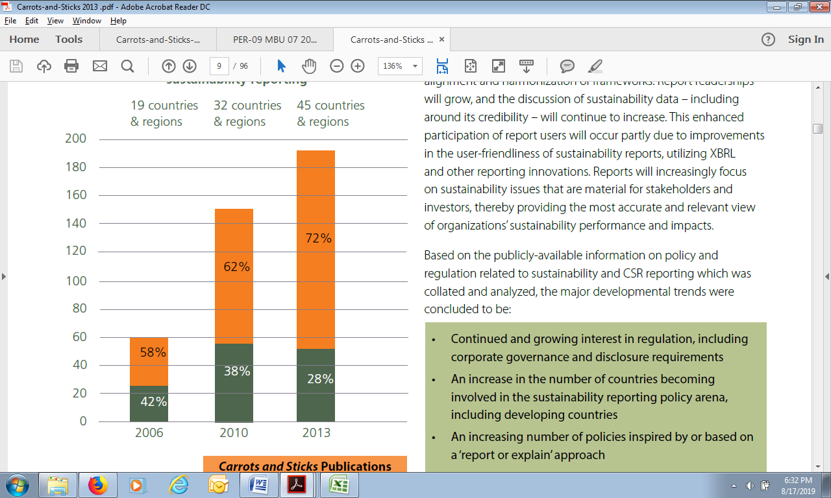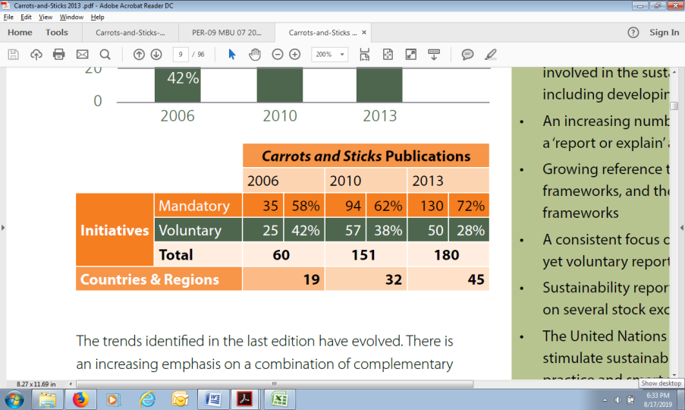
Figure 1
Sustainability Reporting Trends (Mandatory and Voluntary)
Source: Carrots & Sticks (2013)

The trend continued to develop, where there was an increasing emphasis on the complementary combination between voluntary approaches and mandatory approaches for organizational disclosure. There was a gradual integration of organizational performance data, with efforts to combine corporate governance, finance, and sustainability reporting.

Findings in the 2016 Carrots & Sticks Report

Table 2
Trends in Sustainability Reporting Instruments
Source: Carrots & Sticks (2016)

Table 3
Countries and Regions Researched in the 2016 Carrots & Sticks Report
Source: Carrots & Sticks (2016)

There was an increase in the number of reporting instruments that had been identified since the 2013 Carrots & Sticks report. The 2016 Carrots & Sticks report identified nearly 400 sustainability reporting instruments in 64 countries compared to 180 sustainability reporting instruments in 44 countries in the 2013 report. Reporting instruments in Europe, Asia Pacific, and Latin America were growing very strongly.
Government regulation was the largest proportion of instruments for sustainability reporting worldwide. With government instruments, more than 80 percent of countries in the world introduced some forms of sustainability reporting regulatory instruments. Mandatory instruments still dominated, but the growth of voluntary instruments was also quite strong. About two-thirds of the instruments were mandatory and about one-third were voluntary.
The level of activity of the stock market and financial market regulators was an important note in the 2016 Carrots & Sticks report, where the two groups together were responsible for almost one-third of all sustainability reporting instruments that had been successfully identified. Nearly a third of the reporting instruments applied exclusively to large listed companies and around three quarters had been introduced by financial market regulators and stock exchanges. The remaining two-thirds applied to all companies and state-owned companies. Meanwhile, most reporting instruments covered all sectors (cross-sectoral scope). There were also reporting instruments that targeted certain sectors (such as the financial sector and heavy industry). The number of reporting instruments for companies in the financial services sector doubled or even more from 2013 to 2016 and accounted for nearly 40 percent of sector-specific instruments.

SR Instruments in the World in 2016

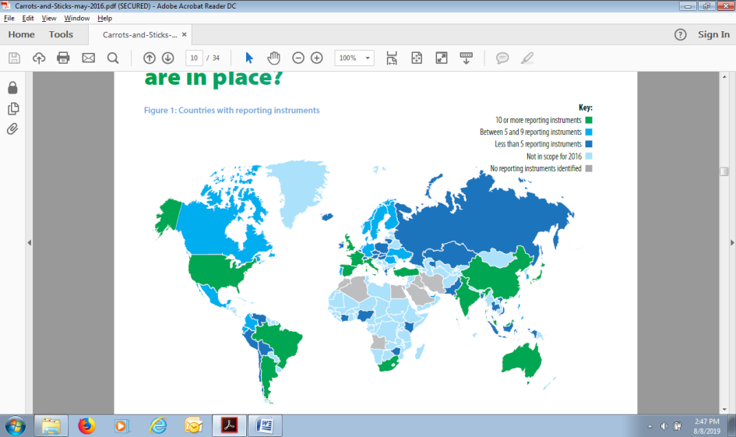
Figure 2
Country and its SR Instruments
Source: Carrots & Sticks (2016)

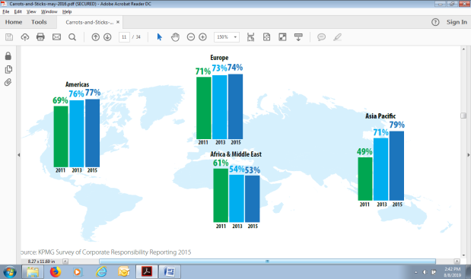
Figure 3
SR level among 100 Big Companies in a Country in 2011 - 2015
Source: KPMG Survey of Corporate Responsibility Reporting 2015

Over the past three years, the total number of instruments that require or encourage organizations to report information about their sustainability performance has grown rapidly and significantly throughout the world. The 2016 Carrots & Sticks report found that sustainability reporting instruments had already existed in most of the world's largest economies: 64 out of 71 countries studied in 2016 had several types of sustainability reporting instruments. In the 2016 report there were 383 sustainability reporting instruments in 64 countries compared to 180 instruments in 44 countries in the 2013 report.
There was a fundamental trend of increasing the volume of reporting instruments: an average of 6.0 instruments per country studied in 2016 compared to an average of 4.1 instruments per country in 2013. This upward trend was supported by the fact that most (around 70 percent) of the new instruments identified in 2016 were carried out in countries that were also covered in 2013. This showed that the market was becoming more complex and modern and was increasingly hoping for businesses to report information not only on financial performance but also on the material aspects of non-financial performance.
There have been rapid developments in Europe, Asia Pacific and Latin America due to the main driver of growth in regulation with the "comply or explain" reporting approach and increased activity by financial market regulators and stock exchanges.

Mandatory and Voluntary Instruments

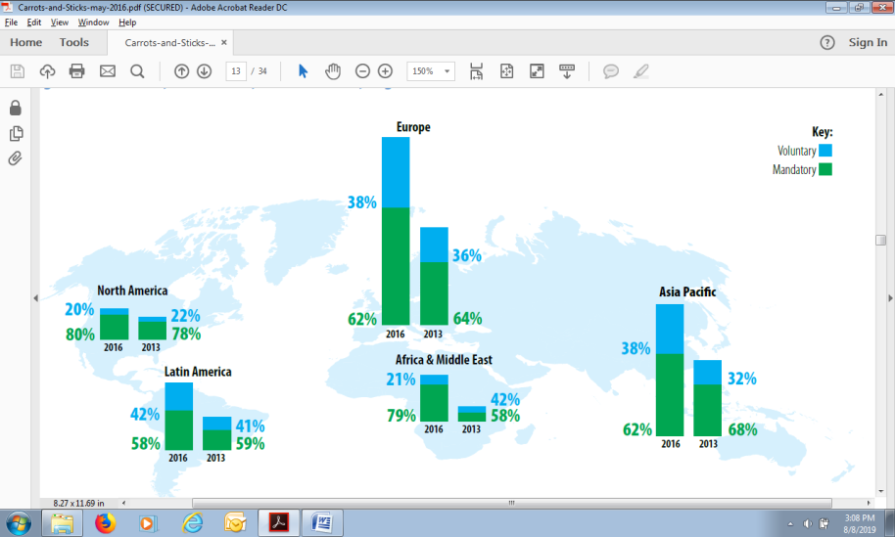
Figure 4
Comparison between Mandatory and Voluntary Instruments
Source: Carrots & Sticks (2016)

The majority of instruments identified in the 2016 Carrots & Sticks Report, around two thirds of the total were mandatory and about one third were voluntary. There were 115 new mandatory instruments. The proportion of mandatory instruments compared to voluntary instruments dropped to 65 percent of the total in 2016, compared to 72 percent in 2013. In the Carrots & Sticks Report for three editions (2006, 2010 and 2013), trends for the proportion of mandatory instruments always increased.
In many countries, initial voluntary reporting efforts by companies to measure and report on their corporate responsibility or sustainability performance have been followed by increased mandatory disclosure requirements introduced through government regulations. This is especially the case in OECD countries, where new reporting requirements have been introduced through laws such as company actions and accounting regulations, as well as instruments that address reporting on specific themes such as corporate governance and the environment.
The thing to note in the European region is the emergence of mandatory requirements from the government or the European Union Commissions (EU Commissions) which require reporting not only on certain environmental or social issues but also on non-financial performance. One example is the historical evolution from the EU Accounts Modernization Directive (2003) to the EU Non-Financial Reporting Directive (2014).

Organizations that Establish SR Instruments

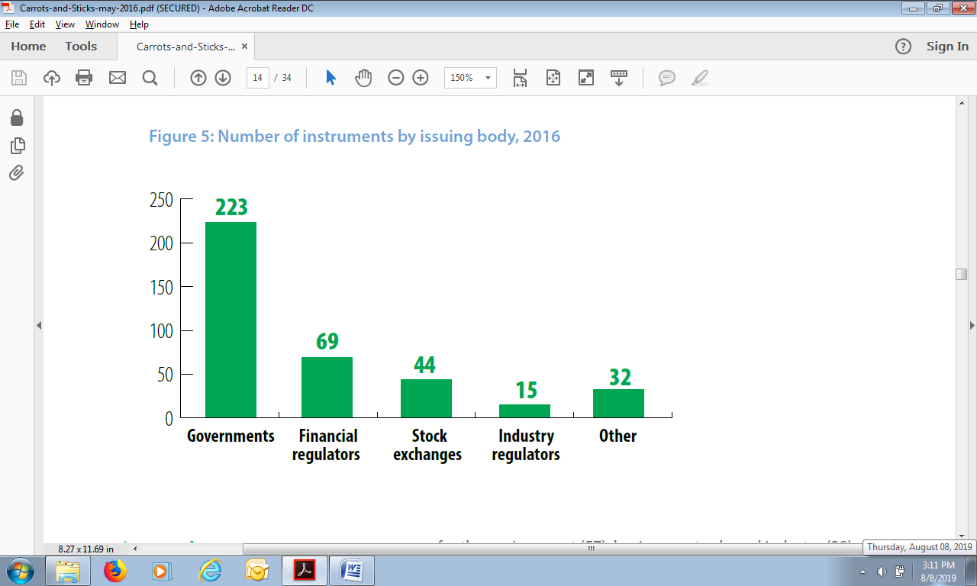
Figure 5
Number of Instruments Issued by the Institution
Source: Carrots & Sticks (2016)

According to the 2016 Carrots & Sticks Report, government regulations constituted the largest proportion of sustainability reporting instruments worldwide, with almost three-fifths of the total instruments identified. Governments in more than 80 percent of countries had established sustainability reporting regulatory instruments (ie 52 countries out of 64 countries). This also happened in 2013, in which 37 countries out of 44 countries used government regulations. Nearly half of government regulations came from European countries (104 out of 223).
The government is the most common issuer of sustainability reporting instruments, but this does not mean that all government instruments require sustainability reporting. More than a quarter or 56 out of 223 government instruments identified in 2016 were voluntary. In addition, it is also important to consider which part of the government that issues reporting instruments (for example laws, regulations, guidelines, or action plans).

Sustainability Reporting Format Required by the Instrument

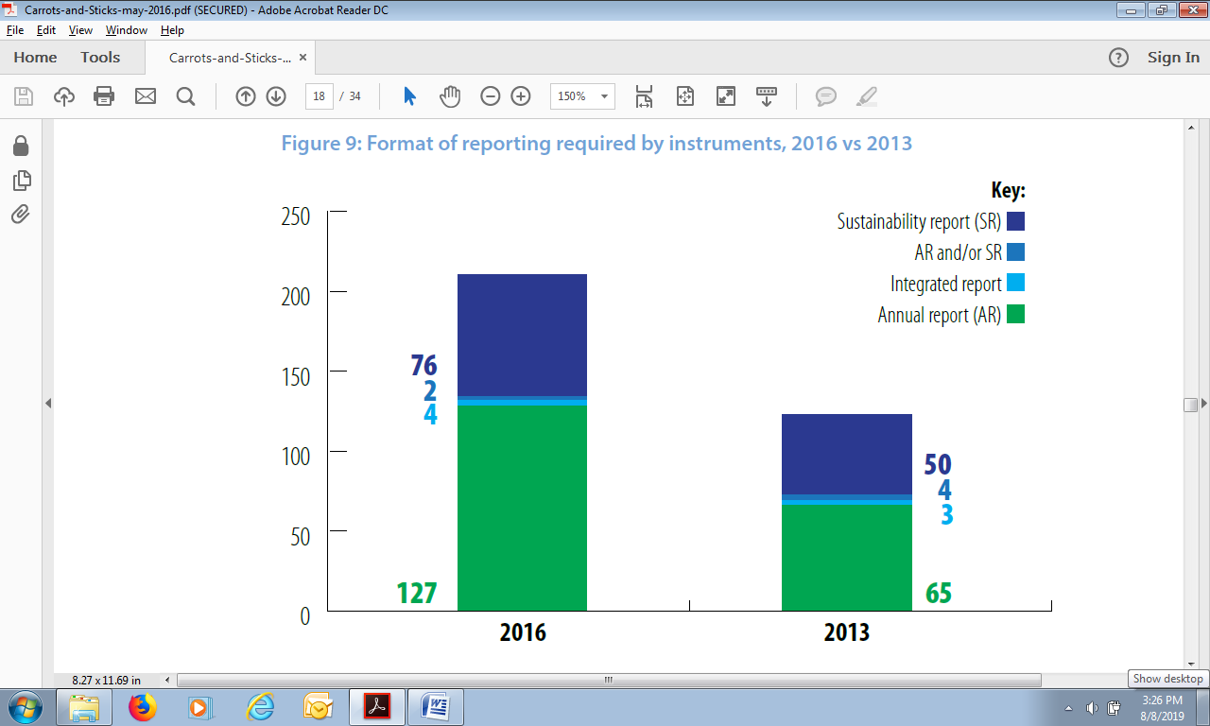
Figure 6
Reporting Format According to Instruments in 2013 and 2016
Source: Carrots & Sticks (2016)

The government and regulators encouraged companies to disclose their sustainability information in annual reports. The number of reporting instruments that required this provision grew from 67 to 127 instruments from 2013 to 2016. This increase was due to the fact that more countries studied in 2016 were also associated with greater pressure from financial institutions, especially investors and institutions, which aimed to improve information about the relevance of material sustainability risks. Reporting instruments that required self-disclosure in sustainability reports also increased but in lower proportions. The number of instruments that determined disclosures in annual reports increased by almost 100 percent while the number of instruments that determined disclosures in sustainability reports increased by more than 50 percent.
About 45 percent of the instruments identified in 2016 required or encouraged companies to disclose their sustainability information in other ways (for example in the forms other than annual financial reports, integrated reports or independent sustainability reports). These other forms might include disclosure of data to independent governments such as greenhouse gas emissions, waste figures, or publication of policies or action plans on certain themes such as labor, social impacts or biodiversity.

The Focus of the Instrument

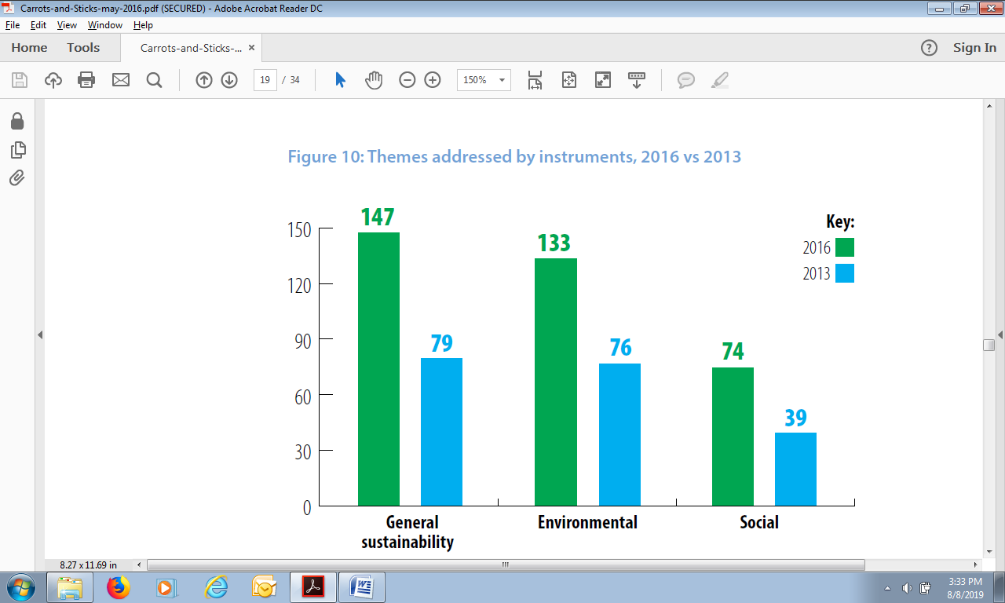
Figure 7 The Theme Raised by the Instruments in 2013 and 2016
Source: Carrots & Sticks (2016)

The first sequence was dominated by general sustainability themes and then focused on environmental and social themes. More than three-fifths (61 percent) of the instruments identified in the 2016 Carrots & Sticks Report explained environmental or social topics. The remaining two-fifths encouraged the reporting of sustainability information in general.
The number of instruments focusing on reporting social information has almost doubled since 2013 compared to instruments focusing on reporting environmental information. The social information covered by this instrument includes human rights, health and safety, working conditions and training. As many as 46 percent of instruments that focus on reporting social information are in European countries, and around 25 percent are in Asia Pacific countries including Australia, Malaysia, China and Japan.

5. CONCLUSION AND SUGGESTION
Conclusion
- The 2016 Carrots & Sticks report explained that of the 71 countries studied, there were 64 countries that had SR instruments consisting of 248 mandatory instruments and 135 voluntary instruments. This was inseparable from the role of regulators in the stock market and financial markets.
- The portion of mandatory instrument was two thirds of the total and voluntary instrument was one third of the total. One of the reasons was due to the shift of instruments that were initially voluntary to become mandatory instruments (especially in OECD countries).
- The parties that determined SR instruments were the government, financial regulators, stock exchanges, industrial regulators and other institutions. The institution that set the largest SR instrument was the government, that is, three-fifths of the total instruments.
- The sustainability information format required by the instrument consisted of Sustainability Report (SR), Annual Report (AR), and Integrated Report (IR). The government and regulators encouraged companies to disclose company sustainability information in an annual report (AR) of 127 instruments. In addition, there were instruments that required reporting sustainability information in SR (76 instruments), in AR / SR (2 instruments) and in IR (4 instruments).
- The focus / theme raised by the instrument consisted of general sustainability, environment and social. 147 instruments focused on the theme of general sustainability, 133 instruments focused on environmental themes and 74 instruments focused on social themes.
- In Indonesia there are eight mandatory SR instruments, such as SOE Ministerial Regulation No. SE-443 / MBU / 2003; Law No.40 / 2007; SOE Minister Regulation No. KEP-05 / MBU / 2007; Regulation No. KEP-431 / BL / 2012; Government Regulation No. 47/2012; Regulation No. 24/2012; SOE Minister Regulation No. PER-09 / MBU / 07/2015; and Decree of the Chairperson of the Capital Market Supervisory Agency No.KEP-431 / BL / 2012.

Suggestion
The government is the main institution that has the power to create sustainability reporting instruments. As of 2016, Indonesia only had eight mandatory SR instruments. The role of the Indonesian government is needed to improve the quality of company sustainability information in Indonesia. Information about sustainability does not have to be in SR format, but it can be in AR format. The most important thing is not the format of the report, but the content of the information conveyed in the report.

REFERENCES
Arthur, Clement Lamboi., Wu, Junjie., Yago, Milton & Zhang, Jinhua. 2017. Investigating Performance Indicators Disclosure in Sustainability Reports of Large Mining Companies in Ghana. Corporate Governance: The International Journal of Business in Society. Vol. 17 Issue: 4. pp.643-660.
Augustine, Yvonne & Kristaung Robert. 2013. Metodologi Penelitian Bisnis dan Akuntansi. Dian Rakyat. Jakarta.
Bellringer, Amber., Ball, Amanda. & Craig, Russell. 2011. Reasons for Sustainability Reporting by New Zealand Local Governments. Sustainability Accounting, Management and Policy Journal. Vol. 2 Issue: 1.pp.126-138.
Bhatia, Aparna & Tuli, Siya. 2017. Corporate Attributes Affecting Sustainability Reporting: an Indian Perspective. International Journal of Law and Management. Vol. 59 Issue: 3. pp.322-340.
Branco, Manuel Castelo., Delgado, Catarina., Gomes, Sónia Ferreira. & Eugénio, Teresa Cristina Pereira. 2014. Factors Influencing the Assurance of Sustainability Reports in the Context of the Economic Crisis in Portugal. Managerial Auditing Journal. Vol. 29 Issue: 3. pp.237-252.
Brinkmann, Robert. 2016. Introduction to Suistainability. Wiley Blackwell.
Buallay, Amina. 2018. Is Sustainability Reporting (ESG) Associated with Performance? Evidence from the European Banking Sector. Management of Environmental Quality: An International Journal.
Bugin, Burhan. 2008. Penelitian Kualitatif: Komunikasi, Ekonomi, Kebijakan Publik dan Ilmu Sosial Lainnya. Kencana. Jakarta.
Christofi, Andreas., Christofi, Petros. & Sisaye, Seleshi. 2012. Corporate Sustainability: Historical Development and Reporting Practices. Management Research Review. Vol. 35 Issue: 2. pp.157-172.
Fitriasari, Dewi. & Kawahara, Naoko. 2018. Japan Investment and Indonesia Sustainability Reporting: an Isomorphism Perspective. Social Responsibility Journal.
Gomes, Sónia Ferreira., Eugénio, Teresa Cristina Pereira. & Branco, Manuel Castelo. 2015. Sustainability Reporting and Assurance in Portugal. Corporate Governance. Vol. 15 Issue: 3. pp.281-292.
Iyer, Venkataraman. & Lulseged, Ayalew. 2013. Does Family Status Impact US Firms' Sustainability Reporting? Sustainability Accounting, Management and Policy Journal. Vol. 4 Issue: 2. pp.163-189.
Joseph, Corina. 2013. Understanding Sustainable Development Concept in Malaysia. Social Responsibility Journal. Vol. 9 Issue: 3. pp.441-453.
Kaur, Amanpreet & Lodhia, Sumit K. 2014. The State of Disclosures on Stakeholder Engagement in Sustainability Reporting in Australian Local Councils. Pacific Accounting Review. Vol. 26 Issue: 1/2. pp.54-74.
KPMG’s Global Sustainability Services & United Nations Environment Programme. 2006. Carrots and Sticks for Starters: Current Trends and Approaches in Voluntary and Mandatory Standards for Sustainability Reporting.
KPMG, United Nations Environment Programme, Unit for Corporate Governance in Africa & The Global Reporting Initiatives. 2010. Carrots and Sticks – Promoting Transparency and Sustainability: An Update on Trends in Voluntary and Mandatory Approaches to Sustainability Reporting.
KPMG, United Nations Environment Programme, Unit for Corporate Governance in Africa & The Global Reporting Initiatives. 2013. Carrots and Sticks: Sustainability Reporting Policies Worldwide – Today’s Best Practice, Tomorrow’s Trend.
KPMG, United Nations Environment Programme, Unit for Corporate Governance in Africa & The Global Reporting Initiatives. 2016. Carrots and Sticks: Global Trends in Sustainability Reporting Regulation and Policy.
Marx, Ben & van Dyk, Vanessa. 2011. Sustainability Reporting and Assurance: An Analysis of Assurance Practices in South Africa. Meditari Accountancy Research. Vol. 19 Issue: 1/2. pp.39-55.
National Center for Sustainability Reporting. 2015. https://www.ncsr-id.org. diunduh 27 Desember 2019.
National Center for Sustainability Reporting. 2016. https://www.ncsr-id.org. diunduh 27 Desember 2019.

Ngu, Sie Bing., & Amran, Azlan. 2018. Materiality Disclosure in Sustainability Reporting: Fostering Stakeholder Engagement. Strategic Direction. Vol. 34 Issue: 5. pp.1-4.
Panuluh, Sekar. & Fitri, Meila Riskia. 2016. Perkembangan Pelaksanaan Sustainabel Development Goals (SDGs) di Indonesia. September 2015 – September 2016.International NGO Forum on Indonesian Development. www. Infid.org. https://www.sdg2030indonesia.org/an-component/media/upload-book/Briefing_paper_No_1_SDGS_-2016-Meila_Sekar.pdf. Diunduh 27 Desember 2019.
Peraturan Presiden Republik Indonesia. 2017. Nomor 59 Tahun 2017. Tentang Pelaksanaan Pencapaian Tujuan Pembangunan Berkelanjutan.
Rankin, Michaela., Stanton, Patricia., McGowan, Susan., Ferlauto, Kimberly. & Tilling, Matthew. 2012. Contemporary Issues in Accounting. John Wiley & Sons. Australia.
Shamil, Mohamed M., Shaikh, Junaid M., Ho, Poh-Ling. & Krishnan, Anbalagan. 2014. The Influence of Board Characteristics on Sustainability Reporting: Empirical Evidence from Sri Lankan Firms. Asian Review of Accounting. Vol. 22 Issue: 2. pp.78-97.
Sugiono. 2005. Memahami Penelitian Kualitatif. ALFABETA. Bandung.

ACKNOWLEDGMENT:
This article was presented in MEBC 2019 “Pengembangan Knowledge-Based Economy Pada Institusi Pendidikan Menuju Revolusi Industri 4.0”

