Data envelopment analysis for profitability and marketing in the 10 largest banks in Indonesia

JMV Mulyadi
Pancasila University, Raya Lenteng Agung Street No.56-80, Jakarta 12640

ARTICLE INFO |  | ABSTRACT
Article history:  Received 28 August 2019  Revised 16 October 2019  Accepted 24 October 2019  JEL Classification:  G14  Key words:  profitability, marketing, data envelopment analysis  DOI:  10.14414/tiar.v9i2.1817 |  | The higher competition in banking industry has pushed the banks to increase efficiency both their profitability and marketing. This study aims to assess the efficiency of the 10 largest banks in Indonesia both in terms of profitability and marketing period 2017-2018 using the Data Envelopment Analysis (DEA) method. The results show that from 2017 to 2018, there were 7 banks that consistently obtained good profitability levels. The average bank profitability performance decreased from 2017 to 2018. From the marketing side, with the first input approach, during 2017-2018 there were only 6 banks that consistently obtained good levels of efficiency, while with the second input approach, there were only 5 banks that consistently achieved good efficiency. The average bank marketing performance declined from 2017 to 2018 using the first and second approaches. In general, bank performance in marketing is still below the bank performance in profitability. The implication is that in using DEA, it must be wise in selecting the input variables because they will produce different values.
 |  | ABSTRAK
 |  | Persaingan industri perbankan yang makin tinggi telah mendorong bank bank untuk meningkatkan efisiensi baik dari sisi profitabilitas maupun marketing. Penelitian ini bertujuan untuk menilai efisiensi 10 bank terbesar di Indonesia baik dari sisi profitabilitas maupun marketing periode 2017-2018 dengan menggunakan metode Data Envelopment Analyisis (DEA). Hasilnya menunjukkan bahwa pada 2017 hingga 2018 ada 7 bank yang secara konsisten memperoleh tingkat profitabilitas yang baik. Rata-rata kinerja profitabilitas bank menurun dari 2017 ke 2018. Dari sisi marketing dengan pendekatan input yang pertama, selama 2017-2018 hanya ada 6 bank yang konsisten memeroleh tingkat efisiensi yang baik sedangkan dengan menggunakan pendekatan input yang kedua, hanya ada 5 bank yang konsisten mencapai efisiensi yang baik. Rata-rata kinerja marketing bank menurun dari 2017 ke 2018 baik dengan menggunakan pendekatan pertama maupun kedua. Secara umum kinerja bank dalam marketing masih dibawah kinerja dalam profitabilitas. Implikasinya dalam menggunakan DEA harus bijak dalam pemilihan variabel inputnya karena akan menghasilkan nilai yang berbeda.

1. INTRODUCTION
The stability of a country's financial system depends largely on the stability of the banking system. At present, the competition in the banking sector in Indonesia is quite high. A large number of banks offer a variety of products both in funds and credit. Banks not only compete through product parameters that carry short-term effects, but also build competitive advantage with a long-term perspective. The main contribution to the bank's long-term strategy is the assessment of its activities from the perspective of performance and efficiency. Bank performance can be seen from the internal side such as profitability, and external side such as marketing in the form of the value of its stocks on the stock exchange. All these indicate the efficiency of the bank's operation. The level of bank profitability has continued to decline over the past 5 years due to weak lending margin and the high ratio of non-performing loans (Baihaqi, 2017). Stock price of large banks recorded a significant decline. For example, the stock price of PT Bank Rakyat Indonesia Tbk (BBRI) dropped 3.98% to IDR 4,100 per stock. The stock price of PT Bank Central Asia Tbk (BBCA) dropped 2% to IDR 29,400. The stock price of PT Bank Mandiri Tbk (BMRI) dropped 2.36% to IDR 7,250, and the stock price of PT Bank Negara Indonesia Tbk (BBNI) dropped 1.26% to IDR 7,825 per stock (Baihaqi, 2017).
There are 2 methods used to measure efficiency: Parametric Method and Non-Parametric Method. Parametric method uses econometric techniques to obtain a benchmark of the optimal combination of cost and production functions. One of the tools is Stochastic Frontier Analysis (SFA). The non-parametric method commonly used is Data Envelopment Analysis (DEA). DEA is an approach to identify best practices among Decision Making Units (DMU) of several inputs and outputs (Seiford and Zhu 2011). DEA has advantages over ratio and regression analysis (Mulyadi 2016). If the unit of analysis has multiple inputs and outputs, it will be difficult to analyze with ratio and regression analysis.
Research conducted using the non-parametric DEA methodology revealed that private banks are relatively more efficient than commercial banks (Jyoti Singh et.al, 2016). Ouenniche and Carrales, 2018 used DEA to analyze the efficiency of commercial banks in the UK, and the results showed that the average commercial bank in the UK, both domestic and foreign, had not yet reached the level of efficiency either using overall technical efficiency, pure technical efficiency, or scale efficiency. Othman et al, 2016 conducted a literature review related to measuring the relative efficiency of banks using DEA. Tahir et al, 2009 used DEA to assess bank efficiency. The results showed that domestic banks were relatively more efficient than foreign banks. Lee 2017 used DEA to assess bank efficiency and the results showed that most Korean banks recovered from the worst performance in 2011 and showed similar performance in recent years. Wahyudi, 2018, examined the efficiency of banking for ASEAN-5 countries using DEA. The results showed a relatively high level of efficiency of each bank in each country. Al-Faraj, 1993 used the DEA to assess commercial bank branches in Saudi Arabia to evaluate the relative efficiency of branches.
This study uses the DEA model Cook and Zhu (2014) to analyze the profitability and marketing of the 10 largest banks in Indonesia. This research is expected to be able to explain the condition of the banks both in terms of profitability (internal) and the marketing of the banks as reflected in the value of stock on the exchange (external). From the DEA model, there will also be a potential improvement, which is a recommendation for the efforts the bank must make in order to achieve good performance. This research is expected to be able to contribute to academically and practically assessing the bank performance using DEA.

2. THEORETICAL FRAMEWORK
Data Envelopment Analysis (DEA) is the application of Linear Program to assess the efficiency of similar units that have the same goals. The units can mean bank, branch, work unit or product. DEA was introduced first by Charnes, Cooper & Rhodes 1978 with the assumption of constant return to scale (CRS), then in 1984 the variable of return to scale (VRS) was introduced by Banker, Charnes and Cooper (Seiford and Zhu 2011). DEA efficiency is measured by linking total output to total input and is expressed in percent. An efficient unit is the unit that gets a value of 100%. DEA analysis has several benefits in scoring and ranking, performance improvement, benchmarking, resource allocation, optimum oriental scale and cross efficiency analysis (Mulyadi 2016).
The DEA Model formulation is measured in a certain way. As an example, this study will compares the p efficiency of a bank. Each bank uses m type of input to produce n type of output. Xip > 0 is the number of input i used by bank to p; Yjp > 0 is the number of output j generated by bank to p. The decision variable of the case is the weight that must be given to each input and output by the bank to p. For example, Uik is the weight given to input i by the bank to k. Vjk is the weight given to output j by the bank to k. So Uik and Vjk are decision variables, the variables whose value will be determined through a linear program. We then formulate a number of fractional linear programs of p, one formulation of a linear program for each bank in the sample. The objective function of each fractional linear program is the ratio of the total weighted output from the bank to k divided by the total weighted input.
The objective function formula which is the efficiency value is as follows:
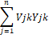
MaximumZk= _______________________________ (1)
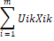
The universality criterion requires the bank to k to choose a weight with the limitation / constraint that no other bank will have efficiency greater than 1 or 100%. If the other banks use the weight chosen by the bank to k, the next formulation is:

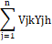
____________ ≤1 ; h = 1, ...........n (2)

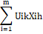

The selected weight may not be in negative value:
Vjk ≥ 0 ; j = 1,………s (3)
Uik ≥ 0 ; i = 1,………m (4)

The fractional linear program is then transformed into a linear program with DEA as follows:
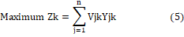
With limitations / constraints:
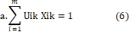
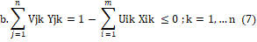
c. Uik ≥ 0, i = 1,2, ……., m, (8)
d. Vjk ≥ 0, j = 1,2, ……., n, (9)

Cook and Zhu, 2014 developed the DEA model with two stages, that is, analyzing the efficiency of a DMU through two stages: the output from the first stage to the input to the second stage.
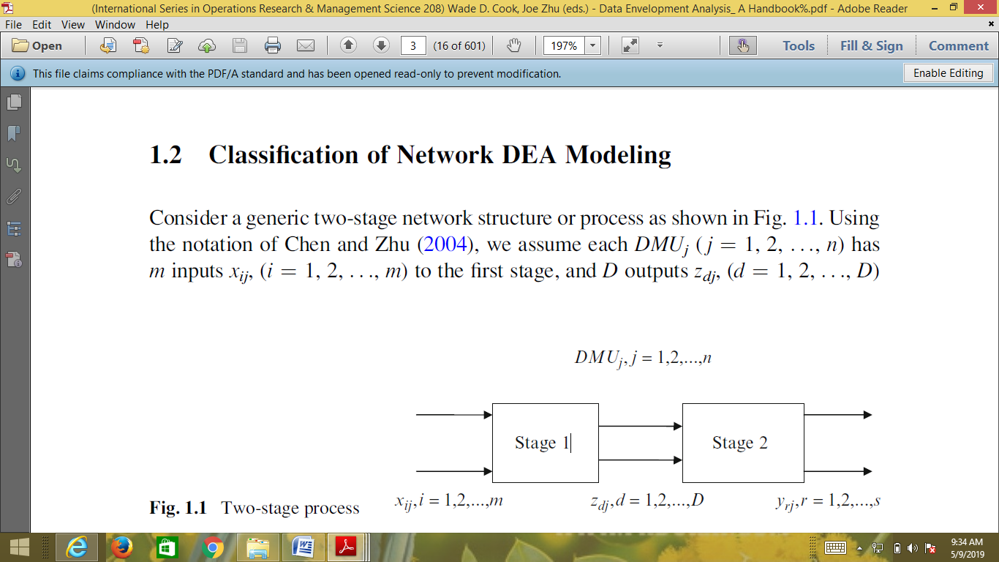

Based on Fig. 1.1, Cook and Zhu (2014) assumed that each DMUj (j ¼ 1, 2... n) has m inputs xij, (i ¼ 1, 2... m) at stage 1, and D is outputs zdj, (d ¼ 1, 2... d). Then output D becomes input at stage 2 and will become a further measure. Outputs from stage 2 are yrj, (r ¼ 1, 2... s). The efficiency of stage 1 is given notation e1j and stage 2 is given notation e2j. By using Constant Returns to Scale (CRS), the efficiency at stages 1 and 2 is obtained as follows:

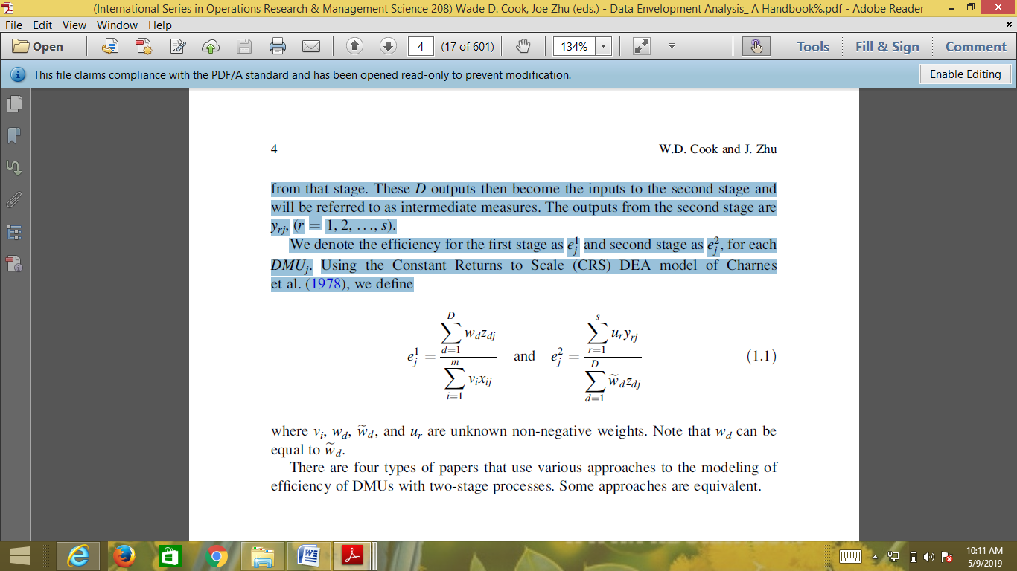
Note:
vi, wd, ewd, and ur the weight may not be in negative and wd can be the same as ewd.

Seiford and Zhu used a two-stage network structure to measure the profitability and marketing of US commercial banks. In their study, profitability was measured relative to labor and assets as inputs while the output was profit and income. In the second stage, for marketing, profit and income are used as input, while market values, returns, and earnings per share are outputs (Seiford and Zhu (1999) in (Cook and Zhu, 2014). Research on efficiency of 46 private banks and the Indian public sector was conducted from 2010 to 2014 using the non-parametric DEA methodology. This research found that private banks were relatively more efficient than commercial banks. This research also found that the managerial inefficiencies were the main cause for the overall technical inefficiencies of private banks rather than scale inefficiencies. On the other hand, the main cause of technical inefficiencies of public banks for several years is the scale inefficiency, not managerial inefficiency. In addition, on average, the difference between the efficiency score of private banks and that of public banks was not statistically significant, except the scale efficiency which was significant for three years in a row, 2010, 2011 and 2012 (Jyoti Singh et al. 2016).
The results of research using DEA to analyze the efficiency of Commercial Banks in the UK show that the average commercial banks in the UK, both domestic and foreign, have not reached the level of efficiency either overall technical efficiency, pure technical efficiency, or scale efficiency (Ouenniche and Carrales 2018). Literature review related to the measurement of the relative efficiency of banks using DEA is measured through the ability of each bank to maximize output at certain input levels. By measuring its efficiency, the researcher make it as the function of an early warning or benchmark of its performance and can determine future improvements in various fields such as managerial, technology or socioeconomic (Othman et al. 2016).
The results of the use of DEA to assess the efficiency of Malaysian commercial banks during the 2000-2006 period showed that domestic banks are relatively more efficient than foreign banks. The results of parametric and non-parametric tests show that for 2000-2004, both domestic and foreign banks have the same technology, while the results for 2005 and 2006 show the opposite. This implies that banks have recently had access to different and more efficient technologies (Tahir et al. 2009). The results of research using DEA to assess the efficiency of banks in Korea with negative data showed that most Korean banks recover from the worst performance in 2011 and show similar performance in recent years. Among the three groups, such as national banks, regional banks, and special banks, special banks show outstanding performance across all models and years. The difference in performance between special banks and regional banks is statistically significant. The high performance of specialized banks is due to market access and their type of national ownership (Lee 2017).
The results of research on the efficiency of Islamic banks in Indonesia using DEA ​​and Tobit models, involving 10 Islamic commercial banks in Indonesia 2011 – 2014, show that the average efficiency of Islamic banks in Indonesia is at a fairly good level with an average score of 91.82, which means that although it is relatively inefficient, Islamic commercial banks in Indonesia can optimize input resources to produce output as an intermediary institution.
The results of research by applying the Tobit model using assets (ASSET), non-performing financing (NPF), capital adequacy ratio (CAR), number of bank branches (BRANCH) and return on assets (ROA) as explanatory variables show that the variables of asset, number of bank branches, and ROA have a significant influence on the efficiency of Islamic commercial banks, while the variables of CAR and NPF empirically have no significant effect on efficiency (Farandy et al 2017).
The results of the study using DEA to assess the efficiency of banks in Czech Slovakia showed that the three largest banks in Slovakia proved to be efficient in the two years analyzed and were efficient in all models with various combinations of inputs and outputs.
Grmanová and Ivanová 2018 examined banking efficiency for ASEAN-5 countries, consisting of Indonesia, Malaysia, the Philippines, Singapore, and Thailand using Data Envelopment Analysis (DEA). The input variable consists of employee benefits, fixed assets, and deposits; while the output variable consist of total income and loans. The results show a relatively high level of efficiency of each bank in each country. Achievement of input-output efficiency variables in the first period (2006-2009) tended to increase, but in the second period (2010-2013) showed a declining trend. The performance of banks in Singapore during the first period was very good, and in the second period, banks in Singapore and the Philippines showed very good performance (Wahyudi 2018).
Research using DEA to assess the efficiency of bank branches in Queensland concluded that accounting variable can be supplemented by non-accounting variable that can be controlled by management (Avkiran 1999).
The research using DEA was conducted to assess branches of commercial banks in Saudi Arabia to evaluate the relative efficiency of branches in order to improve service quality and to use the available resources more efficiently (Al-Faraj 1993). The results of research on the efficiency of Islamic Commercial Banks (BUS) in Indonesia 2013-2015 using DEA show that of the 11 Islamic Commercial Banks, only 5 achieved good efficiency (Miranti and Sari 2016). The results of the research on efficiency using DEA in 6 Islamic commercial Banks in Indonesia 2014-2015 showed that only Panin Bank Dubai Syariah that was consistently efficient (Puspitasari et al 2017).
The result of research on the determinant of Indonesian banking efficiency using DEA ​​period 2012-2014 showed that the banks, proven to have the highest efficiency were foreign bank groups, state-owned commercial banks, non-foreign exchange national private banks, foreign exchange national private banks, and mixed bank groups (Sari and Saraswati 2017).
The result of research on banks’ efficiency listed on the Indonesia Stock Exchange (ISE) using DEA ​​and its effect on stock returns period 2004-2008 showed that out of 16 banks, only 6 banks that had not achieved an efficiency score within 5 years and there was no effect of banking efficiency in Indonesia on stock returns (Qurniawati 2013). The result of research on efficiency in 26 Regional Development Banks (BPD) in Indonesia using DEA showed that the average BPD efficiency was 93.2%. 12 banks had reached 100% efficiency while 14 other BPDs were not efficient (<100%), in carrying out their operation. Central Java Bank was the Regional Development Bank (BPD) which had the lowest efficiency level of 78.6%. Interest expense was the major cause of inefficiency in BPD. Therefore, BPD could improve efficiency by reviewing interest rate policies and increasing lending so that the input issued was in accordance with its output with reference to the BPD which had reached an efficient level (Sutanto 2015).
The result of research using DEA method in BPRS in the Central Java region during the period 2005-2010 showed that the average efficiency was 95.19, and no bank that could achieve optimal efficiency 100% in one-year span (Yahya 2012). The result of research using DEA method for all banks in Indonesia in the category of Commercial Bank Business Activity (BUKU) 4 for the period 2012-2017 provided empirical evidence that Indonesian banking had 100% efficiency. The research showed that the level of efficiency was able to drive high business results and increased competitiveness for banks in the category of Commercial Bank Business Activity (BUKU) 4 (Sari and Widaninggar 2018).

3. RESEARCH METHOD
This is an explanatory research with the aim to examine the efficiency of the 10 largest banks in Indonesia using the Data Envelopment Analysis (DEA) model. The data were taken from each bank's financial statement from the Financial Service Authority (OJK) official website in 2017 and 2018 and from Investing.com for stock market value data. The bank size was assessed based on its assets at the end of 2017 and 2018. The ten banks are: BRI, Mandiri, BCA, BNI, BTN, NIAGA, PANIN, DANAMON, MAYBANK and NISP. This study measures bank efficiency in terms of profitability and marketing, using input and output variables as presented on Table 1.

Table 1
Input and Output Variables
Explanation | Input | Output
Profitability | - Total Assets  - Labor Costs | - Earnings  - Operating Income
Marketing (1) | - Earnings  - Operating Income | - Market value  - Returns  - Earnings per share
Marketing (2) | - Total Assets  - Labor Costs | - Market value,  - Returns  - Earnings per share
Note:

- The values of total assets, labor costs, and operating income are based on the bank's financial statements at the end of 2017 and 2018.
- Market value is the stock price based on a report from Investing.com
- Return = [stock price t- (t-1) + Dividend per stock] / t-1 stock price
- Earnings per stock = earnings/ number of stocks outstanding.

- ANALYSIS AND DISCUSSION
The discussion was carried out by first presenting the output of the DEA software in the form of profitability and marketing efficiency values. Then, the potential improvement was done by each bank in order to achieve good efficiency.

The Value of Bank Profitability Efficiency 2017 - 2018
From the result of the DEA analysis, this study obtained the ranking of the profitability efficiency values for each bank as on Table 2 (Mulyadi 2016). The value of 100% means that the bank’s performance is good, a value of 90% - 99%, the bank's performance is fairly good, and a value below 90%, the performance is not good.

Table 2
The Values of Profitability Efficiency
Bank | 2018 | Bank | 2017
BCA | 100.00% | BCA | 100.00%
BNI | 100.00% | BNI | 100.00%
BRI | 100.00% | BRI | 100.00%
DANAMON | 100.00% | DANAMON | 100.00%
MAYBANK | 100.00% | MAYBANK | 100.00%
NISP | 100.00% | NISP | 100.00%
PANIN | 100.00% | PANIN | 100.00%
MANDIRI | 90.90% | BTN | 93.50%
NIAGA | 76.20% | MANDIRI | 91.00%
BTN | 71.70% | NIAGA | 74.50%
Average | 93.88% | Rata-rata | 95.90%

Based on information on Table 2, it can be seen that during 2017-2018 there were 7 banks that consistently obtained good profitability performance, namely BCA, BNI, BRI, DANAMON, MAYBANK and NISP. Next, the banks that received fairly good profitability performance were Bank Mandiri in 2017 and 2018, Bank BTN had good profitability only in 2017, while Bank Niaga underperformed (not good) during the observation period. The average value of the bank's profitability performance decreased from 2017 to 2018 (in accordance with the phenomenon), although it was still in fairly good category. The result of this study does not support the research conducted by Sari and Widaninggar (2018) which found that large banks were able to optimize their resources to increase their income. Bank Mandiri had assets of IDR 1,202 trillion at the end of 2018, the second largest after BRI, but its profitability performance was lower than that of BNI, BCA, PANIN, DANAMON, MAYBANK and NISP whose assets were under Bank Mandiri. Likewise, in 2017 Bank Mandiri had assets of IDR 1,124 trillion, the second largest after BRI, but its profitability performance was also still lower than that of BNI, BCA, PANIN, DANAMON, MAYBANK and NISP whose assets were under Bank Mandiri. The same thing also happened to the profitability performance of Bank BTN and Niaga. At the end of 2018 they had assets of IDR 306 trillion and IDR 256 trillion respectively, and in 2017 IDR 261 trillion and IDR 255 trillion, however, their profitability performance was still below Bank PANIN, DANAMON, MAYBANK and NISP whose assets were lower.
Other information generated by DEA software is about potential improvements that must be made in order to achieve maximum efficiency as shown on Table 3 and Table 4.

Table
Table 3
Potential Improvement in Profitability 2017
Input / Output | BTN | Mandiri | Niaga
Assets | -16.00% | -19.69% | 0.00%
Labor Costs | 0.00% | 0.00% | 0.00%
Earnings | 6.91% | 9.84% | 47.33%
Operating Income | 6.91% | 9.84% | 34.15%

Based on the information on Table 3, these banks wanted to maximize their profitability. Bank BTN and Bank Mandiri could improve their profitability performance (Mulyadi 2016) over the banks with maximum profitability by increasing their profit and operating income or reducing their assets. Compared with the other eight banks, Bank BTN and Bank Mandiri had large composition of non-earning assets so that their profitability was quite good. Bank Niaga had to increase its operating profit and income in order to achieve a maximum profitability. The results of this study support the research conducted by Avkiran, 1999, that DEA can be used as benchmarking for banks with a maximum profitability.

Table 4
Potential Improvement in Profitability 2018
Input / Output | Mandiri | Niaga | BTN
Assets | -14.95% | 0.00% | -12.24%
Labor Cost | 0.00% | 0.00% | 0.00%
Earnings | 9.97% | 64.11% | 79.48%
Operating Income | 9.97% | 31.28% | 39.42%

Table 4 provides information on how much an increase in output or a decrease in input is if these banks want to maximize their profitability. It can be seen that the banks that obtain efficiency value category “fairly good” (above 90%), such as Bank Mandiri, the percentage of increase in output is smaller than those which have category “not good”. The details can be explained as follows: Bank Mandiri must increase its operating profit and income or reduce its unproductive assets. Bank Niaga must increase its profit and operating income. Bank BTN must increase its profit and operating income or reduce unproductive assets.

Value of marketing efficiency 2017 and 2018
The valuation of marketing efficiency was done using the input variables, consisting of earnings and operating income, and the output variables, consisting of market value, return, and EPS (Seiford and Zhu (2014). The efficiency values are presented on Table 5.

Table 5
The Value of Marketing Efficiency
Bank | 2018 | Bank | 2017
BCA | 100.00% | BCA | 100.00%
BRI | 100.00% | BRI | 100.00%
BTN | 100.00% | BTN | 100.00%
DANAMON | 100.00% | DANAMON | 100.00%
NISP | 100.00% | NISP | 100.00%
PANIN | 100.00% | PANIN | 100.00%
BNI | 58.00% | MAYBANK | 100.00%
MANDIRI | 51.10% | BNI | 94.10%
MAYBANK | 39.70% | NIAGA | 74.10%
NIAGA | 27.60% | MANDIRI | 37.90%
Average | 77.64% | Average | 90.61%

Based on the information in Table 5, it can be seen that in 2017 and 2018, there were 6 banks that consistently obtained maximum level of efficiency, with category “good”, namely BCA, BRI, BTN, DANAMON, NISP and Bank PANIN. Bank MAYBANK reached the category “good” only in 2017 while in 2018, it obtained the category “less good. Bank BNI obtained category “fairly good” in 2017. Bank Mandiri recorded the lowest in 2017 and Bank Niaga recorded the lowest in 2018. The average level of marketing efficiency decreased from 2017 to 2018 with the category “less good”.
To increase the value of efficiency and obtain “good” category, the banks can make efforts as shown on Table 6.

Table 6
Potential Improvement in Marketing Efficiency 2017
Input / output | BNI | Mandiri | Niaga
Market Value | 6.23% | 163.71% | 149.64%
Return | 6.23% | 372.82% | 34.95%
EPS | 6.23% | 163.71% | 128.14%

Based on the information on Table, in order to achieve the "good" category, each bank must increase its market value, return, and EPS. Bank Mandiri must increase the market value, return, and EPS to the largest in percentage followed by Bank Niaga and Bank BNI, because the value of efficiency of Bank Mandiri is the lowest compared to Bank Niaga and BNI.

Table 7
Potential Improvement in Marketing Efficiency 2018
Input / Output | BNI | Mandiri | Maybank | Niaga
Market Value | 72.27% | 227.19% | 441.37% | 261.81%
Return | 100.23% | 95.67% | 152.08% | 8787.97%
EPS | 72.27% | 95.67% | 321.07% | 261.81%

Based on Table 7, in order to reach the "good" category, each bank must increase their market value, return, and EPS. Bank Niaga made the highest improvement effort, followed by Bank Maybank, Mandiri, and BNI according to the ranking of the efficiency value of each bank as on Table 6: Bank BNI, Mandiri, Maybank and Niaga.

Analysis of Bank Marketing 2018 and 2017 with Different Input Variables
DEA analysis was done to assess the marketing bank with the input variables of assets and labor costs and the output variables of market value, return and EPS. The results are presented on Table 8. Based on the information on Table 8, it can be seen that there were 5 banks whose marketing efficiency was consistently good (100%) in 2017 and 2018, namely BCA, BRI, DANAMON, NISP and PANIN. Bank BTN reached 100% in 2017 but dropped in 2018 to 89.50%. In 2017 Bank BNI only reached “fairly good” category, or 94.10% while other banks were in category “less good”. The average level of marketing efficiency decreased from 2017 to 2018 with “less good” category. The results of this study does not support the research conducted by Sari and Widaninggar (2018), the banks with large assets are able to use economic scale. The marketing performance of Bank Mandiri which had the second largest asset after BRI turned out to be under Bank BCA, BTN, Danamon, NISP, and PANIN in 2017 and 2018.

Table 8
The Value of Bank Marketing Efficiency
Bank | 2018 | Bank | 2017
BCA | 100.00% | BCA | 100.00%
BRI | 100.00% | BRI | 100.00%
DANAMON | 100.00% | DANAMON | 100.00%
NISP | 100.00% | NISP | 100.00%
PANIN | 100.00% | PANIN | 100.00%
BTN | 89.50% | BTN | 100.00%
MANDIRI | 50.00% | BNI | 94.10%
BNI | 49.40% | MAYBANK | 83.60%
MAYBANK | 36.40% | NIAGA | 71.10%
NIAGA | 19.10% | MANDIRI | 36.90%
Rata-rata | 74.44% | Rata-rata | 88.57%

Banks that do not achieve maximum marketing efficiency value can make improvement as on Tables 9 and Table 10. The improvement that must be done is in accordance with the value of efficiency obtained on Table 8. The lower the value, the greater the effort that must be done.

Table 9
Potential Improvements in 2018
Input / output | BNI | BTN | Mandiri | Maybank | Niaga
Market Value | 102.38% | 11.76% | 252.27% | 687.96% | 423.62%
Return | 102.38% | 942.58% | 99.90% | 174.58% | 35028.68%
EPS | 102.38% | 11.76% | 99.90% | 395.33% | 423.62%

Table 10
Potential Improvement in 2017
Input / output | BNI | Mandiri | Maybank | Niaga
Market Value | 6.23% | 171.20% | 615.90% | 181.18%
Return | 6.23% | 369.51% | 19.68% | 40.60%
EPS | 6.23% | 171.20% | 458.16% | 146.88%

- CONCLUSION, SUGGESTION, AND RECOMMENDATION
In 2017 and 2018, there were 7 banks that consistently obtained good profitability performance, namely BCA, BNI, BRI, DANAMON, MAYBANK and NISP. Next, the bank that obtained fairly good profitability performance was Bank Mandiri in 2017 and 2018 while Bank BTN obtained good profitability only in 2017. Bank Niaga underperformed during the observation period. The average value of the bank's profitability performance decreased from 2017 to 2018, although it is still in “fairly good” category.
Based on the efficient use of bank resources in marketing in 2017 and 2018, there were 6 banks that consistently obtained a maximum level of efficiency (“good” category), namely Bank BCA, BRI, BTN, DANAMON, NISP and Bank PANIN. Bank MAYBANK obtained “good” category only in 2017 while in 2018, it obtained “less good” category. Bank BNI got “fairly good” category in 2017. Bank Mandiri recorded the lowest in 2017. And Bank Niaga recorded the lowest in 2018. The average level of marketing efficiency decreased from 2017 to 2018 with a “less good” category.
Based on the performance evaluation of bank marketing using the input variables of total assets and labor costs, there were only 5 banks that consistently had good marketing efficiency (100%) in 2017 and 2018, namely BCA, BRI, DANAMON, NISP and PANIN. Bank BTN reached 100% in 2017 but dropped to 89.50% in 2018. In 2017, Bank BNI only reached “fairly good” category, or 94.10% while the other banks were in “less good” category. The average level of marketing efficiency decreased from 2017 to 2018 in the “”less good” category. The efficiency of using banking resources for marketing was lower than profitability. Banks that do not achieve maximum efficiency can improve their efficiency as given in their respective potential improvement.
Based on the conclusion above, the DEA model can be used to assess the efficiency of banking performance in Indonesia because the result shows that the profitability and marketing declined from 2017 to 2018 supporting the phenomenon that profitability as measured by ROA and bank marketing as measured by bank stock prices also decreased.
The next researchers can use other variables that can be implemented in a two-stage DEA model such as: the first stage is marketing and the second stage, profitability or the first stage, technological improvement and HR development and the second stage, profitability. This study only examined the 10 largest banks in Indonesia with only 2 year-observation from 2017 to 2018. For that reason, it might not reflect the overall condition of the banks in Indonesia operating in various segments and markets.

REFERENCES
Al‐Faraj, T. N., Alidi, A. and Bu‐Bshait, K. A. 1993. ‘Evaluation of Bank Branches by Means of Data Envelopment Analysis’, International Journal of Operations & Production Management, 13(9), pp. 45–52.
E-paper kontan.co.id News Data Financial Tool, Saham perbankan tergerus bersama IHSG, ini rekomendasi selanjutnya, Rabu, 7 Agustus 2019.
Farandy, A. R., Suwito, D. A. and Dabutar, L. K. 2017. ‘Efficiency Of Islamic Banks In Indonesia ’:, International Journal of Economics, management and Accounting, 2(2), pp. 337–354.
Grmanová, E. and Ivanová, E. 2018. ‘Efficiency of banks in Slovakia : Measuring by DEA models’, Journal of International Studies, 11(1), pp. 257–272. doi: 10.14254/2071-8330.2018/11-1/20.
Jyoti Singh, A. K. Vashisht, Meena Sharma. 2016. ‘Efficiency Analysis of Indian Commercial Banks: A DEA Approach’, International Journal of Banking, Risk and Insurance, pp 27-38.
K., Avkiran. Necmi. 1999. ‘An application reference for data envelopment analysis in branch banking: helping the novice researcher’, International Journal of Bank Marketing. MCB UP Ltd, 17(5), pp. 206–220. doi: 10.1108/02652329910292675.
Kartika Sari, N. and Widaninggar, N. 2018. ‘Efisiensi Bank dalam Kelompok BUKU 4 di Indonesia : Pendekatan Data Envelopment Analysis’, AFRE Accounting and Financial Review, 1(2), pp. 86–92.
Lee, Y. J., Joo, S.-J. and Park, H. G. 2017. ‘An application of data envelopment analysis for Korean banks with negative data’, Benchmarking: An International Journa, 24(4), pp. 1052–1064.
Miranti, D. A. and Sari, K. 2016. ‘Efisiensi bank umum syariah di indonesia menggunakan pendekatan’, Jurnal Ekonomi dan Bisnis, 21(3), pp. 194–200.
Muhamad Bari Baihaqi. 2017. Tingkat Profitabilitas Perbankan Terus Menurun, Harian Ekonomi Neraca, Jumat, 20 September 2019, E-paper.
Mulyadi JMV. 2016. Aplikasi Data Envelopment Analysis pada Perbankan Indonesia, Lintang Pustaka Utama Yogyakarta, cetakan pertama, Juli 2016.
Othman, F. M. et al. 2016. ‘Data Envelopment Analysis : A Tool of Measuring Efficiency in Banking Sector’, International Journal of Economics and Financial Issues, 6(3), pp. 911–916.
Ouenniche, J. and Carrales, S. 2018. ‘Assessing efficiency profiles of UK commercial banks : a DEA analysis with regression-based feedback’, Annals of Operations Research. Springer US, 266(1), pp. 551–587. doi: 10.1007/s10479-018-2797-z.
Puspitasari, A., Purnomo, D. and Triyono, T. 2017. ‘Penggunaan Data Envelopment Analysis ( DEA ) Dalam Pengukuran Efisiensi Bank Umum Syariah Di Indonesia’, Jurnal Bisnis dan Manajemen Islam, 5(2), pp. 293–304.
Qurniawati, R. S. 2013. ‘Efisiensi Perbankan Di Indonesia Dan Pengaruhnya terhadap Return Saham dengan Pendekatan Data Envelopment Analysis ( DEA )’, Benefit Jurnal Manajemen dan Bisnis, 17(1), pp. 27–40.
Sari, P. Z. and Saraswati, E. 2017. ‘The Determinant of Banking Efficiency in Indonesia (DEA Approach)’, Journal of Accounting and Business Education, 1(2), pp. 208–229.
Seiford, L. M. and Zhu, J. 2011. Data Envelopment Analysis : History , Models , and Interpretations Chapter 1. doi: 10.1007/978-1-4419-6151-8.
Singh, J., Vashisht, A. K. and Sharma, M. 2016. ‘Efficiency Analysis of Indian Commercial Banks : A DEA Approach’, International Journal of Banking, Risk and Insurance, 4(2), pp. 27–38.
Sutanto, A. H. 2015. ‘Analisis efisiensi teknis bank pembangunan daerah’, Jejak Journal of Economics and Policy, 8(1), pp. 23–35. doi: 10.15294/jejak.v8i1.3851.
Tahir, M. I., Abu-Bakar, N. M. and Haron, S. 2009. ‘Evaluating Efficiency of Malaysian Banks Using Data Envelopment Analysis’, International Journal of Business ang Management, 4(8), pp. 96–106.
Wade D. Cook and Joe Zhu. 2014. ‘Data Envelopment Analysis A Handbook on the Modeling of Internal Structures and Networks’ Chapter 1. DOI 10.1007/978-1-4899-8068-7
Wahyudi, S. T. and Azizah. 2018. ‘A Comparative Study of Banking Efficiency In Asean-5 : The Data Envelopment Analysis (DEA) Approach’, Journal of Indonesia Economy and Business, 33(2), pp. 168–186.
Yahya, M. 2012. ‘Menakar Efisiensi BPRS Sebagai Bank Pembiayaan Rakyat’, Ekuitas jurnal Ekonomi dan Keuangan, 18(1), pp. 56–76.
Zhu, J. 2015. International Series in Operations Research & Management Science Associate Series Editor.

