**Hasil Output PLS**

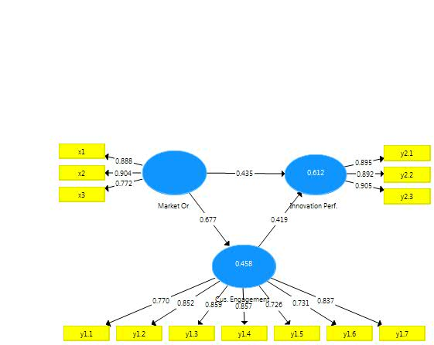

|  |  |  |  |  |  |  |  |
| --- | --- | --- | --- | --- | --- | --- | --- |
| **Outer Loadings** | | | |  | |  | |
|  | |  | |  | |  | |
|  | | Cus. Engagement | | Innovation Perf. | | Market Or | |
| x1 | |  | |  | | 0.888 | |
| x2 | |  | |  | | 0.904 | |
| x3 | |  | |  | | 0.772 | |
| y1.1 | | 0.770 | |  | |  | |
| y1.2 | | 0.852 | |  | |  | |
| y1.3 | | 0.859 | |  | |  | |
| y1.4 | | 0.857 | |  | |  | |
| y1.5 | | 0.726 | |  | |  | |
| y1.6 | | 0.731 | |  | |  | |
| y1.7 | | 0.837 | |  | |  | |
| y2.1 | |  | | 0.895 | |  | |
| y2.2 | |  | | 0.892 | |  | |
| y2.3 | |  | | 0.905 | |  | |
| Outer Weights | | |  | |  | |
|  |  | |  | |  | |
|  | Cus. Engagement | | Innovation Perf. | | Market Or | |
| x1 |  | |  | | 0.368 | |
| x2 |  | |  | | 0.443 | |
| x3 |  | |  | | 0.354 | |
| y1.1 | 0.158 | |  | |  | |
| y1.2 | 0.197 | |  | |  | |
| y1.3 | 0.182 | |  | |  | |
| y1.4 | 0.177 | |  | |  | |
| y1.5 | 0.173 | |  | |  | |
| y1.6 | 0.163 | |  | |  | |
| y1.7 | 0.188 | |  | |  | |
| y2.1 |  | | 0.354 | |  | |
| y2.2 |  | | 0.369 | |  | |
| y2.3 |  | | 0.392 | |  | |

|  |  |  |  |
| --- | --- | --- | --- |
| Latent Variable Correlations | |  |  |
|  |  |  |  |
|  | Cus. Engagement | Innovation Perf. | Market Or |
| Cus. Engagement | 1.000 | 0.714 | 0.677 |
| Innovation Perf. | 0.714 | 1.000 | 0.719 |
| Market Or | 0.677 | 0.719 | 1.000 |

|  |  |  |
| --- | --- | --- |
| Quality Criteria | |  |
|  |  |  |
| **R Square** |  |  |
|  |  |  |
|  | R Square | R Square Adjusted |
| Cus. Engagement | 0.458 | 0.456 |
| Innovation Perf. | 0.612 | 0.609 |

|  |  |  |  |  |  |
| --- | --- | --- | --- | --- | --- |
| f Square |  | |  | |  |
|  |  | |  | |  |
|  | Cus. Engagement | | Innovation Perf. | | Market Or |
| Cus. Engagement |  | | 0.246 | |  |
| Innovation Perf. |  | |  | |  |
| Market Or | 0.847 | | 0.265 | |  |
| **Construct Reliability and Validity** | | | |  | | |  |
|  | |  |  |  | | |  |
|  | | **Cronbach's Alpha** | rho_A | **Composite Reliability** | | | Average Variance Extracted (AVE) |
| Cus. Engagement | | 0.909 | 0.913 | 0.928 | | | 0.651 |
| Innovation Perf. | | 0.879 | 0.881 | 0.925 | | | 0.805 |
| Market Or | | 0.816 | 0.832 | 0.891 | | | 0.733 |

Discriminant Validity

|  |  |  |  |
| --- | --- | --- | --- |
| Cross Loadings | |  |  |
|  |  |  |  |
|  | Cus. Engagement | Innovation Perf. | Market Or |
| x1 | 0.536 | 0.589 | 0.888 |
| x2 | 0.661 | 0.693 | 0.904 |
| x3 | 0.529 | 0.552 | 0.772 |
| y1.1 | 0.770 | 0.522 | 0.478 |
| y1.2 | 0.852 | 0.646 | 0.598 |
| y1.3 | 0.859 | 0.600 | 0.549 |
| y1.4 | 0.857 | 0.564 | 0.557 |
| y1.5 | 0.726 | 0.542 | 0.551 |
| y1.6 | 0.731 | 0.542 | 0.490 |
| y1.7 | 0.837 | 0.601 | 0.586 |
| y2.1 | 0.636 | 0.895 | 0.588 |
| y2.2 | 0.668 | 0.892 | 0.608 |
| y2.3 | 0.620 | 0.905 | 0.732 |

**Bootstrapping (Uji Hipotesis dan signifikansi)**

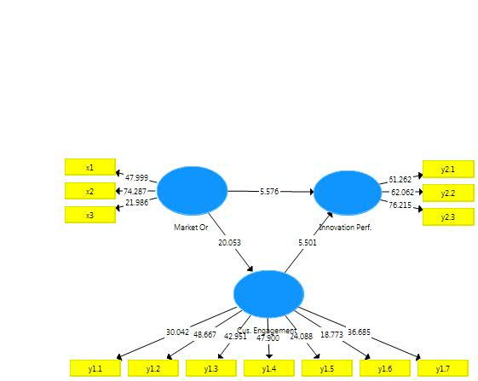

|  |  |  |  |  |  |
| --- | --- | --- | --- | --- | --- |
| Final Results |  |  |  |  |  |
|  |  |  |  |  |  |
| Path Coefficients |  |  |  |  |  |
|  |  |  |  |  |  |
|  |  |  |  |  |  |
| Mean, STDEV, T-Values, P-Values | |  |  |  |  |
|  |  |  |  |  |  |
|  | Original Sample (O) | Sample Mean (M) | Standard Deviation (STDEV) | T Statistics (|O/STDEV|) | P Values |
| Cus. Engagement -> Innovation Perf. | 0.419 | 0.418 | 0.076 | 5.501 | 0.000 |
| Market Or -> Cus. Engagement | 0.677 | 0.681 | 0.034 | 20.053 | 0.000 |
| Market Or -> Innovation Perf. | 0.435 | 0.436 | 0.078 | 5.576 | 0.000 |

|  |  |  |  |  |  |
| --- | --- | --- | --- | --- | --- |
| Total Indirect Effects |  |  |  |  |  |
|  |  |  |  |  |  |
|  |  |  |  |  |  |
| Mean, STDEV, T-Values, P-Values | |  |  |  |  |
|  |  |  |  |  |  |
|  | Original Sample (O) | Sample Mean (M) | Standard Deviation (STDEV) | T Statistics (|O/STDEV|) | P Values |
| Cus. Engagement -> Innovation Perf. |  |  |  |  |  |
| Market Or -> Cus. Engagement |  |  |  |  |  |
| Market Or -> Innovation Perf. | 0.284 | 0.285 | 0.054 | 5.222 | 0.000 |

|  |  |  |  |  |  |
| --- | --- | --- | --- | --- | --- |
| Specific Indirect Effects | |  |  |  |  |
|  |  |  |  |  |  |
|  |  |  |  |  |  |
| Mean, STDEV, T-Values, P-Values | |  |  |  |  |
|  |  |  |  |  |  |
|  | Original Sample (O) | Sample Mean (M) | Standard Deviation (STDEV) | T Statistics (|O/STDEV|) | P Values |
| Market Or -> Cus. Engagement -> Innovation Perf. | 0.284 | 0.285 | 0.054 | 5.222 | 0.000 |

|  |  |  |  |  |  |
| --- | --- | --- | --- | --- | --- |
| Total Effects |  |  |  |  |  |
|  |  |  |  |  |  |
|  |  |  |  |  |  |
| Mean, STDEV, T-Values, P-Values | |  |  |  |  |
|  |  |  |  |  |  |
|  | Original Sample (O) | Sample Mean (M) | Standard Deviation (STDEV) | T Statistics (|O/STDEV|) | P Values |
| Cus. Engagement -> Innovation Perf. | 0.419 | 0.418 | 0.076 | 5.501 | 0.000 |
| Market Or -> Cus. Engagement | 0.677 | 0.681 | 0.034 | 20.053 | 0.000 |
| Market Or -> Innovation Perf. | 0.719 | 0.721 | 0.040 | 18.013 | 0.000 |

|  |  |  |  |  |  |
| --- | --- | --- | --- | --- | --- |
| Outer Loadings |  |  |  |  |  |
|  |  |  |  |  |  |
|  |  |  |  |  |  |
| Mean, STDEV, T-Values, P-Values | |  |  |  |  |
|  |  |  |  |  |  |
|  | Original Sample (O) | Sample Mean (M) | Standard Deviation (STDEV) | T Statistics (|O/STDEV|) | P Values |
| x1 <- Market Or | 0.888 | 0.887 | 0.018 | 47.999 | 0.000 |
| x2 <- Market Or | 0.904 | 0.904 | 0.012 | 74.287 | 0.000 |
| x3 <- Market Or | 0.772 | 0.773 | 0.035 | 21.986 | 0.000 |
| y1.1 <- Cus. Engagement | 0.770 | 0.771 | 0.026 | 30.042 | 0.000 |
| y1.2 <- Cus. Engagement | 0.852 | 0.853 | 0.018 | 48.667 | 0.000 |
| y1.3 <- Cus. Engagement | 0.859 | 0.859 | 0.020 | 42.951 | 0.000 |
| y1.4 <- Cus. Engagement | 0.857 | 0.857 | 0.018 | 47.900 | 0.000 |
| y1.5 <- Cus. Engagement | 0.726 | 0.727 | 0.030 | 24.088 | 0.000 |
| y1.6 <- Cus. Engagement | 0.731 | 0.734 | 0.039 | 18.773 | 0.000 |
| y1.7 <- Cus. Engagement | 0.837 | 0.837 | 0.023 | 36.685 | 0.000 |
| y2.1 <- Innovation Perf. | 0.895 | 0.895 | 0.015 | 61.262 | 0.000 |
| y2.2 <- Innovation Perf. | 0.892 | 0.891 | 0.014 | 62.062 | 0.000 |
| y2.3 <- Innovation Perf. | 0.905 | 0.905 | 0.012 | 76.215 | 0.000 |

|  |  |  |  |  |  |
| --- | --- | --- | --- | --- | --- |
| Outer Weights |  |  |  |  |  |
|  |  |  |  |  |  |
|  |  |  |  |  |  |
| Mean, STDEV, T-Values, P-Values | |  |  |  |  |
|  |  |  |  |  |  |
|  | Original Sample (O) | Sample Mean (M) | Standard Deviation (STDEV) | T Statistics (|O/STDEV|) | P Values |
| x1 <- Market Or | 0.368 | 0.368 | 0.019 | 19.418 | 0.000 |
| x2 <- Market Or | 0.443 | 0.442 | 0.021 | 21.035 | 0.000 |
| x3 <- Market Or | 0.354 | 0.355 | 0.020 | 17.450 | 0.000 |
| y1.1 <- Cus. Engagement | 0.158 | 0.158 | 0.009 | 18.225 | 0.000 |
| y1.2 <- Cus. Engagement | 0.197 | 0.196 | 0.009 | 22.187 | 0.000 |
| y1.3 <- Cus. Engagement | 0.182 | 0.182 | 0.007 | 25.182 | 0.000 |
| y1.4 <- Cus. Engagement | 0.177 | 0.177 | 0.008 | 23.006 | 0.000 |
| y1.5 <- Cus. Engagement | 0.173 | 0.173 | 0.013 | 13.459 | 0.000 |
| y1.6 <- Cus. Engagement | 0.163 | 0.164 | 0.010 | 15.979 | 0.000 |
| y1.7 <- Cus. Engagement | 0.188 | 0.187 | 0.010 | 18.438 | 0.000 |
| y2.1 <- Innovation Perf. | 0.354 | 0.355 | 0.010 | 34.406 | 0.000 |
| y2.2 <- Innovation Perf. | 0.369 | 0.368 | 0.012 | 31.619 | 0.000 |
| y2.3 <- Innovation Perf. | 0.392 | 0.392 | 0.013 | 31.005 | 0.000 |