SIG 1 COMPLETE

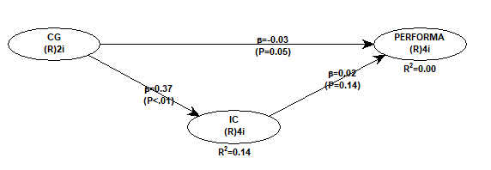

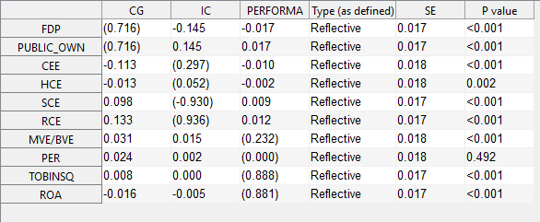

**REVISI MODEL 2**

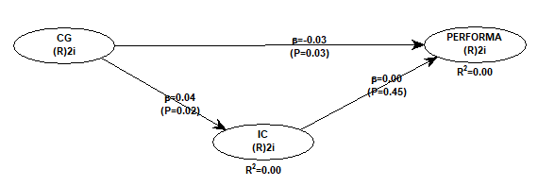

**INDIKATOR LOADINGS & CROSS LOADING**

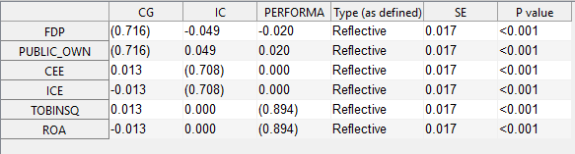

**PATH**

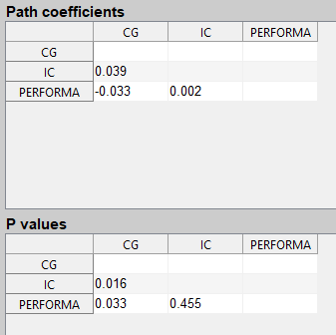

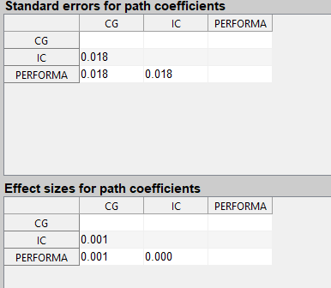

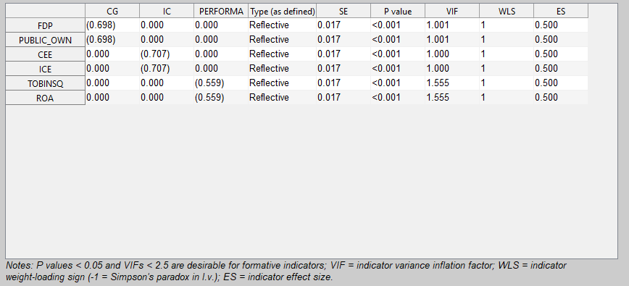

**Model fit and quality indices**

**-----------------------------------------------------------**

**Average path coefficient (APC)=0.025, P=0.043**

**Average R-squared (ARS)=0.001, P=0.236**

**Average adjusted R-squared (AARS)=0.001, P=0.241**

**Average block VIF (AVIF)=1.000, acceptable if <= 5, ideally <= 3.3**

**Average full collinearity VIF (AFVIF)=1.000, acceptable if <= 5, ideally <= 3.3**

**Tenenhaus GoF (GoF)=0.028, small >= 0.1, medium >= 0.25, large >= 0.36**

**Sympson's paradox ratio (SPR)=1.000, acceptable if >= 0.7, ideally = 1**

**R-squared contribution ratio (RSCR)=1.000, acceptable if >= 0.9, ideally = 1**

**Statistical suppression ratio (SSR)=1.000, acceptable if >= 0.7**

**Nonlinear bivariate causality direction ratio (NLBCDR)=0.667, acceptable if >= 0.7**

**General model elements**

**-----------------------------------------------------------**

**Missing data imputation algorithm: Arithmetic Mean Imputation**

**Outer model analysis algorithm: PLS Regression**

**Default inner model analysis algorithm: Warp3**

**Multiple inner model analysis algorithms used? No**

**Resampling method used in the analysis: Stable3**

**Number of data resamples used: 100**

**Number of cases (rows) in model data: 3102**

**Number of latent variables in model: 3**

**Number of indicators used in model: 6**

**Number of iterations to obtain estimates: 3**

**Range restriction variable type: None**

**Range restriction variable: None**

**Range restriction variable min value: 0.000**

**Range restriction variable max value: 0.000**

**Only ranked data used in analysis? No**

**DESCRIPTIVE STATISTICS**

| **Descriptive Statistics** | | | | | |
| --- | --- | --- | --- | --- | --- |
|  | N | Minimum | Maximum | Mean | Std. Deviation |
| FDP | 3102 | .00 | 1.00 | .0809 | .14461 |
| PO | 3102 | .00 | 94.71 | 22.6726 | 18.65754 |
| CEE | 3101 | -58575.09 | 21246.35 | -9.3282 | 1295.01376 |
| ICE | 3102 | -2.00 | 3139310.91 | 6862.4607 | 66148.46457 |
| ROA | 3101 | -97.02 | 119.06 | .1481 | 3.52203 |
| TOBINSQ | 3101 | -373.71 | 1660.28 | 2.5967 | 34.03524 |
| Valid N (listwise) | 3101 |  |  |  |  |