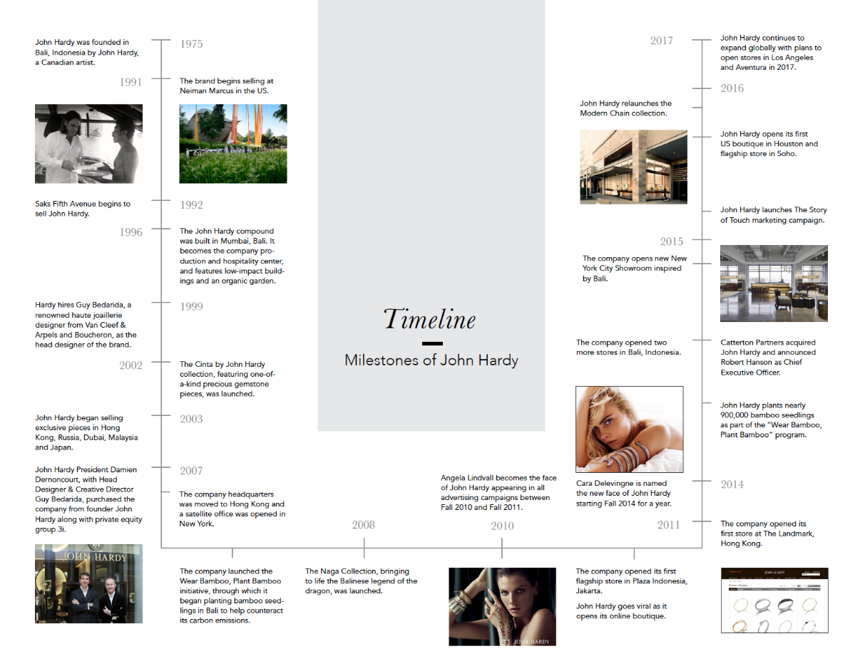

***Picture 1.1***

***Milestones of John Hardy***